






Operate a fast food outlet
D1.HCA.CL3.05
Trainer Guide

Operate a fast food outlet

D1.HCA.CL3.05

Trainer Guide




Project Base
William Angliss Institute of TAFE
555 La Trobe Street
Melbourne 3000 Victoria
Telephone: | (03) 9606 2111
Facsimile: | (03) 9670 1330
Acknowledgements
Project Director: | Wayne Crosbie
Chief Writer: | Alan Hickman
Subject Writer: | Garry Blackburn
Project Manager: | Alan Maguire
Editor: | Jim Irwin
DTP/Production: | Daniel Chee, Mai Vu, Kaly Quach
The Association of Southeast Asian Nations (ASEAN) was established on 8 August 1967. The Member States of the Association are Brunei Darussalam, Cambodia, Indonesia, Lao PDR, Malaysia, Myanmar, Philippines, Singapore, Thailand and Viet Nam.
The ASEAN Secretariat is based in Jakarta, Indonesia.
General Information on ASEAN appears online at the ASEAN Website: www.asean.org.
All text is produced by William Angliss Institute of TAFE for the ASEAN Project on “Toolbox Development for Front Office, Food and Beverage Services and Food Production Divisions”.
This publication is supported by the Australian Government’s aid program through the ASEAN-Australia Development Cooperation Program Phase II (AADCP II).
Copyright: Association of Southeast Asian Nations (ASEAN) 2013.
All rights reserved.
Disclaimer
Every effort has been made to ensure that this publication is free from errors or omissions. However, you should conduct your own enquiries and seek professional advice before relying on any fact, statement or matter contained in this book. The ASEAN Secretariat and William Angliss Institute of TAFE are not responsible for any injury, loss or damage as a result of material included or omitted from this course. Information in this module is current at the time of publication. Time of publication is indicated in the date stamp at the bottom of each page.
Some images appearing in this resource have been purchased from stock photography suppliers Shutterstock and iStockphoto and other third party copyright owners and as such are non-transferable and non-exclusive. Clip arts, font images and illustrations used are from the Microsoft Office Clip Art and Media Library. Some images have been provided by and are the property of William Angliss Institute.
Additional images have been sourced from Flickr and SKC and are used under Creative Commons licence: http://creativecommons.org/licenses/by/2.0/deed.en
File name: TG_Operate_a_fast_food_outlet_FN_030214





Table of contents
Competency Based Training (CBT) and assessment – An introduction for trainers 1
Competency standard 11
Notes and PowerPoint slides 23
Cookery practical classes: Recommended training equipment 57
Instructions for Trainers for using PowerPoint – Presenter View 59
Appendix – ASEAN acronyms 61

Competency Based Training (CBT) and assessment – An introduction for trainers

Competency
Competency refers to the ability to perform particular tasks and duties to the standard of performance expected in the workplace.
Competency requires the application of specified knowledge, skills and attitudes relevant to effective participation, consistently over time and in the workplace environment.
The essential skills and knowledge are either identified separately or combined.
Knowledge identifies what a person needs to know to perform the work in an informed and effective manner.
Skills describe the application of knowledge to situations where understanding is converted into a workplace outcome.
Attitude describes the founding reasons behind the need for certain knowledge or why skills are performed in a specified manner.
Competency covers all aspects of workplace performance and involves:
- Performing individual tasks
- Managing a range of different tasks
- Responding to contingencies or breakdowns
- Dealing with the responsibilities of the workplace
- Working with others.

Unit of Competency
Like with any training qualification or program, a range of subject topics are identified that focus on the ability in a certain work area, responsibility or function.
Each manual focuses on a specific unit of competency that applies in the hospitality workplace.
In this manual a unit of competency is identified as a ‘unit’.
Each unit of competency identifies a discrete workplace requirement and includes:
- Knowledge and skills that underpin competency
- Language, literacy and numeracy
- Occupational health and safety requirements.
Each unit of competency must be adhered to in training and assessment to ensure consistency of outcomes.

Element of Competency
An element of competency describes the essential outcomes within a unit of competency.
The elements of competency are the basic building blocks of the unit of competency. They describe in terms of outcomes the significant functions and tasks that make up the competency.
In this manual elements of competency are identified as an ‘element’.

Performance criteria
Performance criteria indicate the standard of performance that is required to demonstrate achievement within an element of competency. The standards reflect identified industry skill needs.
Performance criteria will be made up of certain specified skills, knowledge and attitudes.

Learning
For the purpose of this manual learning incorporates two key activities:
- Training
- Assessment.
Both of these activities will be discussed in detail in this introduction.
Today training and assessment can be delivered in a variety of ways. It may be provided to participants:
- On-the-job – in the workplace
- Off-the-job – at an educational institution or dedicated training environment
- As a combination of these two options.
No longer is it necessary for learners to be absent from the workplace for long periods of time in order to obtain recognised and accredited qualifications.

Learning Approaches
This manual will identify two avenues to facilitate learning:
Competency Based Training (CBT)
This is the strategy of developing a participant’s competency.
Educational institutions utilise a range of training strategies to ensure that participants are able to gain the knowledge and skills required for successful:
- Completion of the training program or qualification
- Implementation in the workplace.
The strategies selected should be chosen based on suitability and the learning styles of participants.

Competency Based Assessment (CBA)
This is the strategy of assessing competency of a participant.
Educational institutions utilise a range of assessment strategies to ensure that participants are assessed in a manner that demonstrates validity, fairness, reliability, flexibility and fairness of assessment processes.

Flexibility in Learning
It is important to note that flexibility in training and assessment strategies is required to meet the needs of participants who may have learning difficulties. The strategies used will vary, taking into account the needs of individual participants with learning difficulties. However they will be applied in a manner which does not discriminate against the participant or the participant body as a whole.
Catering for Participant Diversity
Participants have diverse backgrounds, needs and interests. When planning training and assessment activities to cater for individual differences, trainers and assessors should:
- Consider individuals’ experiences, learning styles and interests
- Develop questions and activities that are aimed at different levels of ability
- Modify the expectations for some participants
- Provide opportunities for a variety of forms of participation, such as individual, pair and small group activities
- Assess participants based on individual progress and outcomes.
The diversity among participants also provides a good reason for building up a learning community in which participants support each other’s learning.
Participant Centred Learning
This involves taking into account structuring training and assessment that:
- Builds on strengths – Training environments need to demonstrate the many positive features of local participants (such as the attribution of academic success to effort, and the social nature of achievement motivation) and of their trainers (such as a strong emphasis on subject disciplines and moral responsibility). These strengths and uniqueness of local participants and trainers should be acknowledged and treasured
- Acknowledges prior knowledge and experience – The learning activities should be planned with participants’ prior knowledge and experience in mind
- Understands learning objectives – Each learning activity should have clear learning objectives and participants should be informed of them at the outset. Trainers should also be clear about the purpose of assignments and explain their significance to participants
- Teaches for understanding – The pedagogies chosen should aim at enabling participants to act and think flexibly with what they know
- Teaches for independent learning – Generic skills and reflection should be nurtured through learning activities in appropriate contexts of the curriculum. Participants should be encouraged to take responsibility for their own learning
- Enhances motivation – Learning is most effective when participants are motivated. Various strategies should be used to arouse the interest of participants
- Makes effective use of resources – A variety of teaching resources can be employed as tools for learning
- Maximises engagement – In conducting learning activities, it is important for the minds of participants to be actively engaged
- Aligns assessment with learning and teaching – Feedback and assessment should be an integral part of learning and teaching
- Caters for learner diversity – Trainers should be aware that participants have different characteristics and strengths and try to nurture these rather than impose a standard set of expectations.
Active Learning
The goal of nurturing independent learning in participants does not imply that they always have to work in isolation or solely in a classroom. On the contrary, the construction of knowledge in tourism and hospitality studies can often best be carried out in collaboration with others in the field. Sharing experiences, insights and views on issues of common concern, and working together to collect information through conducting investigative studies in the field (active learning) can contribute a lot to their eventual success.
Active learning has an important part to play in fostering a sense of community in the class. First, to operate successfully, a learning community requires an ethos of acceptance and a sense of trust among participants, and between them and their trainers. Trainers can help to foster acceptance and trust through encouragement and personal example, and by allowing participants to take risks as they explore and articulate their views, however immature these may appear to be. Participants also come to realise that their classmates (and their trainers) are partners in learning and solving.
Trainers can also encourage cooperative learning by designing appropriate group learning tasks, which include, for example, collecting background information, conducting small-scale surveys, or producing media presentations on certain issues and themes. Participants need to be reminded that, while they should work towards successful completion of the field tasks, developing positive peer relationships in the process is an important objective of all group work.

Competency Based Training (CBT)
Principle of Competency Based Training
Competency based training is aimed at developing the knowledge, skills and attitudes of participants, through a variety of training tools.
Training Strategies
The aims of this curriculum are to enable participants to:
- Undertake a variety of subject courses that are relevant to industry in the current environment
- Learn current industry skills, information and trends relevant to industry
- Learn through a range of practical and theoretical approaches
- Be able to identify, explore and solve issues in a productive manner
- Be able to become confident, equipped and flexible managers of the future
- Be ‘job ready’ and a valuable employee in the industry upon graduation of any qualification level.
To ensure participants are able to gain the knowledge and skills required to meet competency in each unit of competency in the qualification, a range of training delivery modes are used.
Types of Training
In choosing learning and teaching strategies, trainers should take into account the practical, complex and multi-disciplinary nature of the subject area, as well as their participant’s prior knowledge, learning styles and abilities.
Training outcomes can be attained by utilising one or more delivery methods:
Lecture/Tutorial
This is a common method of training involving transfer of information from the trainer to the participants. It is an effective approach to introduce new concepts or information to the learners and also to build upon the existing knowledge. The listener is expected to reflect on the subject and seek clarifications on the doubts.
Demonstration
Demonstration is a very effective training method that involves a trainer showing a participant how to perform a task or activity. Through a visual demonstration, trainers may also explain reasoning behind certain actions or provide supplementary information to help facilitate understanding.
Group Discussions
Brainstorming in which all the members in a group express their ideas, views and opinions on a given topic. It is a free flow and exchange of knowledge among the participants and the trainer. The discussion is carried out by the group on the basis of their own experience, perceptions and values. This will facilitate acquiring new knowledge. When everybody is expected to participate in the group discussion, even the introverted persons will also get stimulated and try to articulate their feelings.
The ideas that emerge in the discussions should be noted down and presentations are to be made by the groups. Sometimes consensus needs to be arrived at on a given topic. Group discussions are to be held under the moderation of a leader guided by the trainer. Group discussion technique triggers thinking process, encourages interactions and enhances communication skills.
Role Play
This is a common and very effective method of bringing into the classroom real life situations, which may not otherwise be possible. Participants are made to enact a particular role so as to give a real feel of the roles they may be called upon to play. This enables participants to understand the behaviour of others as well as their own emotions and feelings. The instructor must brief the role players on what is expected of them. The role player may either be given a ready-made script, which they can memorize and enact, or they may be required to develop their own scripts around a given situation. This technique is extremely useful in understanding creative selling techniques and human relations. It can be entertaining and energizing and it helps the reserved and less literate to express their feelings.

Simulation Games
When trainees need to become aware of something that they have not been conscious of, simulations can be a useful mechanism. Simulation games are a method based on "here and now" experience shared by all the participants. The games focus on the participation of the trainees and their willingness to share their ideas with others. A "near real life" situation is created providing an opportunity to which they apply themselves by adopting certain behaviour. They then experience the impact of their behaviour on the situation. It is carried out to generate responses and reactions based on the real feelings of the participants, which are subsequently analysed by the trainer.
While use of simulation games can result in very effective learning, it needs considerable trainer competence to analyse the situations.
Individual /Group Exercises
Exercises are often introduced to find out how much the participant has assimilated. This method involves imparting instructions to participants on a particular subject through use of written exercises. In the group exercises, the entire class is divided into small groups, and members are asked to collaborate to arrive at a consensus or solution to a problem.
Case Study
This is a training method that enables the trainer and the participant to experience a real life situation. It may be on account of events in the past or situations in the present, in which there may be one or more problems to be solved and decisions to be taken. The basic objective of a case study is to help participants diagnose, analyse and/or solve a particular problem and to make them internalize the critical inputs delivered in the training. Questions are generally given at the end of the case study to direct the participants and to stimulate their thinking towards possible solutions. Studies may be presented in written or verbal form.
Field Visit
This involves a carefully planned visit or tour to a place of learning or interest. The idea is to give first-hand knowledge by personal observation of field situations, and to relate theory with practice. The emphasis is on observing, exploring, asking questions and understanding. The trainer should remember to brief the participants about what they should observe and about the customs and norms that need to be respected.
Group Presentation
The participants are asked to work in groups and produce the results and findings of their group work to the members of another sub-group. By this method participants get a good picture of each other's views and perceptions on the topic and they are able to compare them with their own point of view. The pooling and sharing of findings enriches the discussion and learning process.
Practice Sessions
This method is of paramount importance for skills training. Participants are provided with an opportunity to practice in a controlled situation what they have learnt. It could be real life or through a make-believe situation.

Games
This is a group process and includes those methods that involve usually fun-based activity, aimed at conveying feelings and experiences, which are everyday in nature, and applying them within the game being played. A game has set rules and regulations, and may or may not include a competitive element. After the game is played, it is essential that the participants be debriefed and their lessons and experiences consolidated by the trainer.
Research
Trainers may require learners to undertake research activities, including online research, to gather information or further understanding about a specific subject area.

Competency Based Assessment (CBA)
Principle of Competency Based Assessment
Competency based assessment is aimed at compiling a list of evidence that shows that a person is competent in a particular unit of competency.
Competencies are gained through a multitude of ways including:
- Training and development programs
- Formal education
- Life experience
- Apprenticeships
- On-the-job experience
- Self-help programs.
All of these together contribute to job competence in a person. Ultimately, assessors and participants work together, through the ‘collection of evidence’ in determining overall competence.
This evidence can be collected:
- Using different formats
- Using different people
- Collected over a period of time.
The assessor who is ideally someone with considerable experience in the area being assessed, reviews the evidence and verifies the person as being competent or not.
Flexibility in Assessment
Whilst allocated assessment tools have been identified for this subject, all attempts are made to determine competency and suitable alternate assessment tools may be used, according to the requirements of the participant.
The assessment needs to be equitable for all participants, taking into account their cultural and linguistic needs.
Competency must be proven regardless of:
- Language
- Delivery Method
- Assessment Method.
Assessment Objectives
The assessment tools used for subjects are designed to determine competency against the ‘elements of competency’ and their associated ‘performance criteria’.
The assessment tools are used to identify sufficient:
- Knowledge, including underpinning knowledge
- Skills
- Attitudes
Assessment tools are activities that trainees are required to undertake to prove participant competency in this subject.
All assessments must be completed satisfactorily for participants to obtain competence in this subject. There are no exceptions to this requirement, however, it is possible that in some cases several assessment items may be combined and assessed together.
Types of Assessment
Allocated Assessment Tools
There are a number of assessment tools that are used to determine competency in this subject:
- Work projects
- Written questions
- Oral questions
- Third Party Report
- Observation Checklist.
Instructions on how assessors should conduct these assessment methods are explained in the Assessment Manuals.
Alternative Assessment Tools
Whilst this subject has identified assessment tools, as indicated above, this does not restrict the assessor from using different assessment methods to measure the competency of a participant.
Evidence is simply proof that the assessor gathers to show participants can actually do what they are required to do.
Whilst there is a distinct requirement for participants to demonstrate competency, there are many and diverse sources of evidence available to the assessor.
Ongoing performance at work, as verified by a supervisor or physical evidence, can count towards assessment. Additionally, the assessor can talk to customers or work colleagues to gather evidence about performance.
A range of assessment methods to assess competency include:
- Practical demonstrations
- Practical demonstrations in simulated work conditions
- Problem solving
- Portfolios of evidence
- Critical incident reports
- Journals
- Oral presentations
- Interviews
- Videos
- Visuals: slides, audio tapes
- Case studies
- Log books
- Projects
- Role plays
- Group projects
- Group discussions
- Examinations.
Recognition of Prior Learning
Recognition of Prior Learning is the process that gives current industry professionals who do not have a formal qualification, the opportunity to benchmark their extensive skills and experience against the standards set out in each unit of competency/subject.
Also known as a Skills Recognition Audit (SRA), this process is a learning and assessment pathway which encompasses:
- Recognition of Current Competencies (RCC)
- Skills auditing
- Gap analysis and training
- Credit transfer.
Assessing competency
As mentioned, assessment is the process of identifying a participant’s current knowledge, skills and attitudes sets against all elements of competency within a unit of competency. Traditionally in education, grades or marks were given to participants, dependent on how many questions the participant successfully answered in an assessment tool.
Competency based assessment does not award grades, but simply identifies if the participant has the knowledge, skills and attitudes to undertake the required task to the specified standard.
Therefore, when assessing competency, an assessor has two possible results that can be awarded:
- Pass Competent (PC)
- Not Yet Competent (NYC).
Pass Competent (PC)
If the participant is able to successfully answer or demonstrate what is required, to the expected standards of the performance criteria, they will be deemed as ‘Pass Competent’ (PC).
The assessor will award a ‘Pass Competent’ (PC) if they feel the participant has the necessary knowledge, skills and attitudes in all assessment tasks for a unit.
Not Yet Competent’ (NYC)
If the participant is unable to answer or demonstrate competency to the desired standard, they will be deemed to be ‘Not Yet Competent’ (NYC).
This does not mean the participant will need to complete all the assessment tasks again. The focus will be on the specific assessment tasks that were not performed to the expected standards.
The participant may be required to:
a) Undertake further training or instruction
b) Undertake the assessment task again until they are deemed to be ‘Pass Competent’.

Competency standard
UNIT TITLE: OPERATE A FAST FOOD OUTLET |  |  |  | NOMINAL HOURS: 45
UNIT NUMBER: D1.HCA.CL3.05
UNIT DESCRIPTOR: This unit deals with skills and knowledge required by cooks and chefs to plan and operate production of a fast food outlet in commercial food production environments
ELEMENTS AND PERFORMANCE CRITERIA | UNIT VARIABLE AND ASSESSMENT GUIDE
Element 1: Plan for fast food production  - Identify large and small equipment requirements for menu and volume  - Identify staff requirements  - Plan a menu to meet establishment and client requirements  - Plan workflow and production schedules  - Prepare standard recipes for menu items  Element 2: Prepare, cook and hold items for fast food outlet  - Use appropriate preparation and cooking methods  - Use appropriate equipment  - Follow food safety requirements  - Hold menu items  - Reheat menu items | Unit Variables  The Unit Variables provide advice to interpret the scope and context of this unit of competence, allowing for differences between enterprises and workplaces. It relates to the unit as a whole and facilitates holistic assessment  This unit applies to all industry sectors that operate fast food outlets within the labour divisions of the hotel and travel industries and may include:  - Food Production  Equipment may include:  Electric, gas or induction stoves  Steamers, including combination oven, pressure, atmospheric, bamboo  Salamanders  Pressure cookers  Smokers  Grills, including direct, indirect, char, BBQ  Ovens, convection ovens, combination ovens  Wok
Element 3: Provide fast food service  - Serve and present food items in line with customer volume  - Maintain a clean customer service area  Element 4: Maintain fast food outlet  4.1 Clean fast food area in line with establishment and equipment requirements  4.2 Undertake stock control and reordering processes  4.3 Identify and report maintenance issues to appropriate personnel  Element 5: Store food items  - Store fresh and/or Cryovac items correctly  - Prepare and maintain correct thawing of food items  - Store fast food products appropriately in correct containers  - Label fast food products correctly  - Ensure correct conditions are maintained for freshness and quality | Tilt pan/bratt pan  Kettles  Deep fry, pressure fryer  Microwave  Food processors  Mixers, mincers  Blenders  Slices, bowl choppers  Hot plates  Rotisseries  Pans and urns  Bain-marie  Food warmers  Staff may include:  Full time, part time and casual  Rosters, schedules  Position descriptions  Qualified, unqualified.
Menu may include:
Hot food
Cold food
Drinks
Hot dogs
Pizza
Fish and chips
Hamburgers
Fried chicken
Sandwiches
Salads
Sushi
Souvlaki, doner kebabs
Noodles and pasta
Soups
Ice cream and shakes
Pies.
Schedules may include:
Mise en place
Kitchen section
Quantities
Opening hours
Service periods.
Standard recipes may relate to:
Presentation standards
Portion control/yields
Ingredients lists
Methods of preparation.
Preparation and cooking methods may include
Chopping, cutting, peeling
Braising
Stewing
Poaching
Boiling, simmering
Steaming, atmospheric and/or pressure
Roasting, pot roasting
Baking
Grilling
Deep and shallow frying
Wrapped food, including vine, banana leaf, paper, bark, paper bag
Microwave
Thawing
Blanching.
Food safety requirements may relate to:
Handling foods
Cross contamination
Hold temperatures and times
Storage of foods
Recording times and temperatures.
Hold menu items may relate to:
Temperature and time controls
Use of appropriate equipment
Recording information.
Reheat menu items may relate to:
Temperature and time controls
Use of appropriate equipment
Recording information
Use of appropriate cooking/reheating methods for menu item.
Serve and present food items may relate to:
Portioning
Temperature
Packaging
Garnish.
Clean customer service area may relate to:
Free of food scraps
Free of liquid spills.
Clean may include:
Sweeping
Washing
Sanitising
Scrubbing
Frequency of cleaning of equipment
Signing off cleaning undertaken.
Stock control may relate to:
Completing stock count on prescribed forms
Noting items that require reordering.
Reordering may relate to:
Recording products required on prescribed forms
Contacting supplier to place order.
Appropriate personnel could include:
Supervisor
Duty managers
Shift managers
Head office.
Store may include:
Cool room temperature
Cool room placement
Length of time in cool storage
Freezer temperature
Length of time in freezer storage
Storage containers before assembly
Storage containers after assembly
Dietary and cultural styles/flavours
Labelled
Freshness, quality and presentation
Temperature and humidity.
Thawing may relate to:
Enterprise and local authority requirements
Handling and cool room placement
Changing containers.
Label must include:
Date
Item name
Handler name
Time, temperature, storage.
Correct conditions should include:
Temperature and humidity
Stock rotation
Reporting faults
Changing containers.
Assessment Guide
The following skills and knowledge must be assessed as part of this unit:
Knowledge of a range of basic cooking skills for fast foods, including a selection as appropriate to the menu:
- Hot plate
- Reheating
- Microwaving
- Baking
- Roasting
- Boiling
- Char-grilling, barbeque
Ability to apply the principles and practices of personal and food hygiene
Ability to apply safe work practices as required by occupational health and safety legislation and guidelines
Demonstrate customer service and communication skills
Knowledge of the range of food offered
Knowledge of waste minimisation techniques and environmental considerations in relation to the operation of a fast food outlet.
Linkages To Other Units
Comply with workplace hygiene procedures
Implement occupational health and safety procedures
Prepare and store food
Work effectively with colleagues and customers
Maintain strategies for safe food storage
Present and display food products
Apply basic techniques of commercial cookery
Prepare a variety of sandwiches
Prepare stock and sauces
Prepare soups
Prepare vegetables, eggs and farinaceous dishes
Identify and prepare various meats
Prepare and cook poultry and game meats
Prepare and cook seafood.
Critical Aspects of Assessment
Evidence of the following is essential:
Demonstrate ability to apply safe and hygienic handling of products
Demonstrate ability to appropriately portion control products
Complementary presentation and garnish
Terminology
Safe food handling
Demonstrate ability to store fast food items to industry and enterprise standards
Demonstrated ability to plan the set up of an identified fast food outlet, including:
- Selection of menu items
- Identification of equipment requirements
- Propose staffing requirements to meet operational needs and workflows
Demonstrate ability to apply the correct cooking, holding and reheating methods to the menu items
Demonstrate ability to maintain the cleanliness and hygienic standards required of a fast food outlet
Demonstrate correct knife skills, use of equipment and utensils
Demonstrate creative and artistic skills in preparation, decoration and display of appetisers and salads.
Context of Assessment
This unit may be assessed on or off the job:
Assessment should include practical demonstration either in the workplace or through a simulation activity, supported by a range of methods to assess underpinning knowledge
Assessment must relate to the individuals work area or area of responsibility
Demonstration of skills on more than one occasion
Preparation and display of various fast food items within typical workplace conditions and timeframes.
Resource Implications
Training and assessment must include access and use to a fully equipped commercial kitchen/fast food outlet, use of real ingredients and service equipment; and access to workplace standards, procedures, policies, guidelines, tools and equipment.
Assessment Methods
The following methods may be used to assess competency for this unit:
Observation of practical candidate performance
Oral and written questions
Third party reports completed by a supervisor
Project and assignment work
Sampling of dishes prepared by the student.
Key Competencies in this Unit
Level 1 = competence to undertake tasks effectively
Level 2 = competence to manage tasks
Level 3 = competence to use concepts for evaluating
 | Key Competencies | Level | Examples
 | Collecting, organising and analysing information | 2 | Determine requirements of standard recipes and/or menu requirements; collect equipment, commodities and ingredients; read menus, recipes and task sheets; select and obtain commodities; organise ingredients and task sheets
 | Communicating ideas and information | 2 | Share information with other kitchen, floor service staff; read recipes, menus, instructions and orders
 | Planning and organising activities | 3 | Work within time restraints in a logical sequence; plan logical and efficient sequencing and timing of tasks; plan venue layout and workflows
 | Working with others and in teams | 3 | Work cooperatively with other team members
 | Using mathematical ideas and techniques | 1 | Calculate portions, weigh and measure quantities against standard recipes and/or menu requirements
 | Solving problems | 2 | Identify and correct problems in preparing and producing products, such as ingredient quality and equipment failure
 | Using technology | 1 | Use mechanical kitchen equipment, including weighing equipment

Notes and PowerPoint slides
Slide
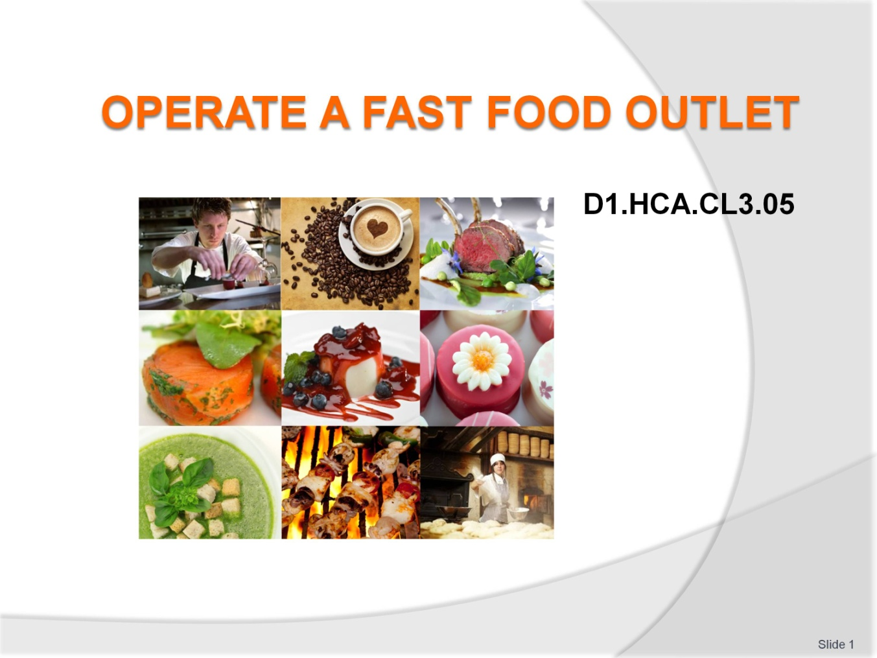
Slide No | Trainer Notes
 | Welcome students to the class.

Slide
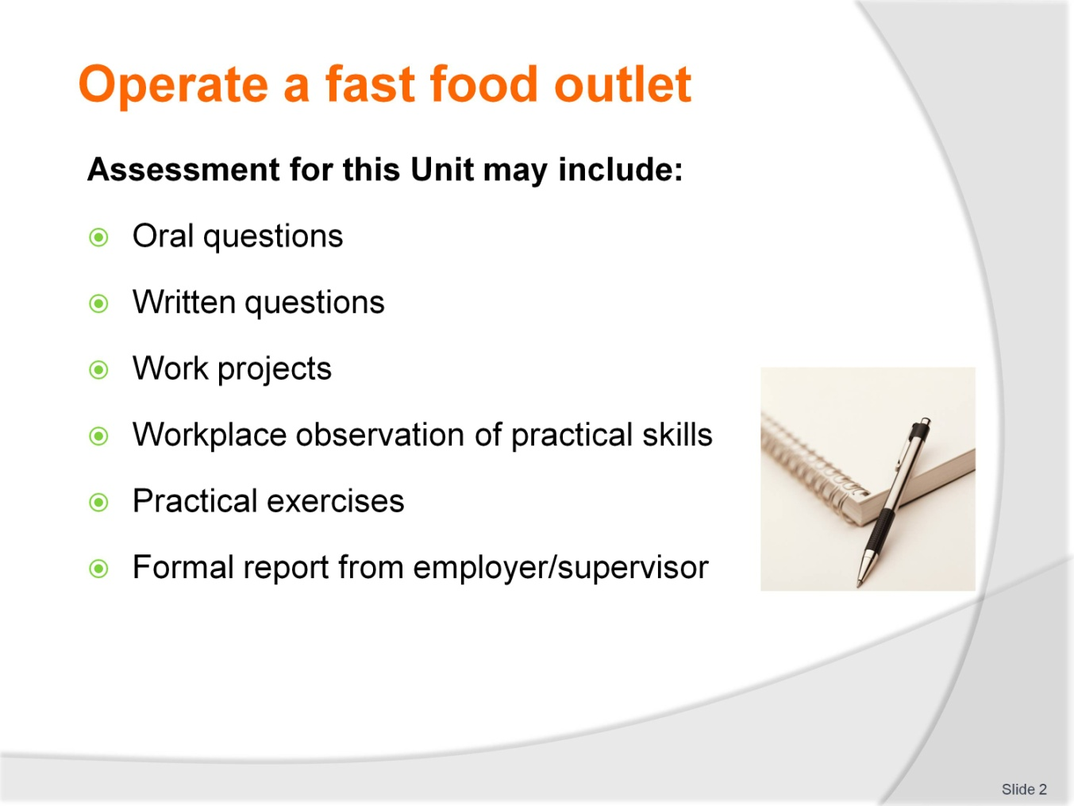
Slide No | Trainer Notes
Trainer to advise
Trainer advises students that assessment for this Unit may take several forms all of which are aimed at verifying they have achieved competency for the Unit as required.
Trainer indicates to students the methods of assessment that will be applied to them for this Unit.

Slide
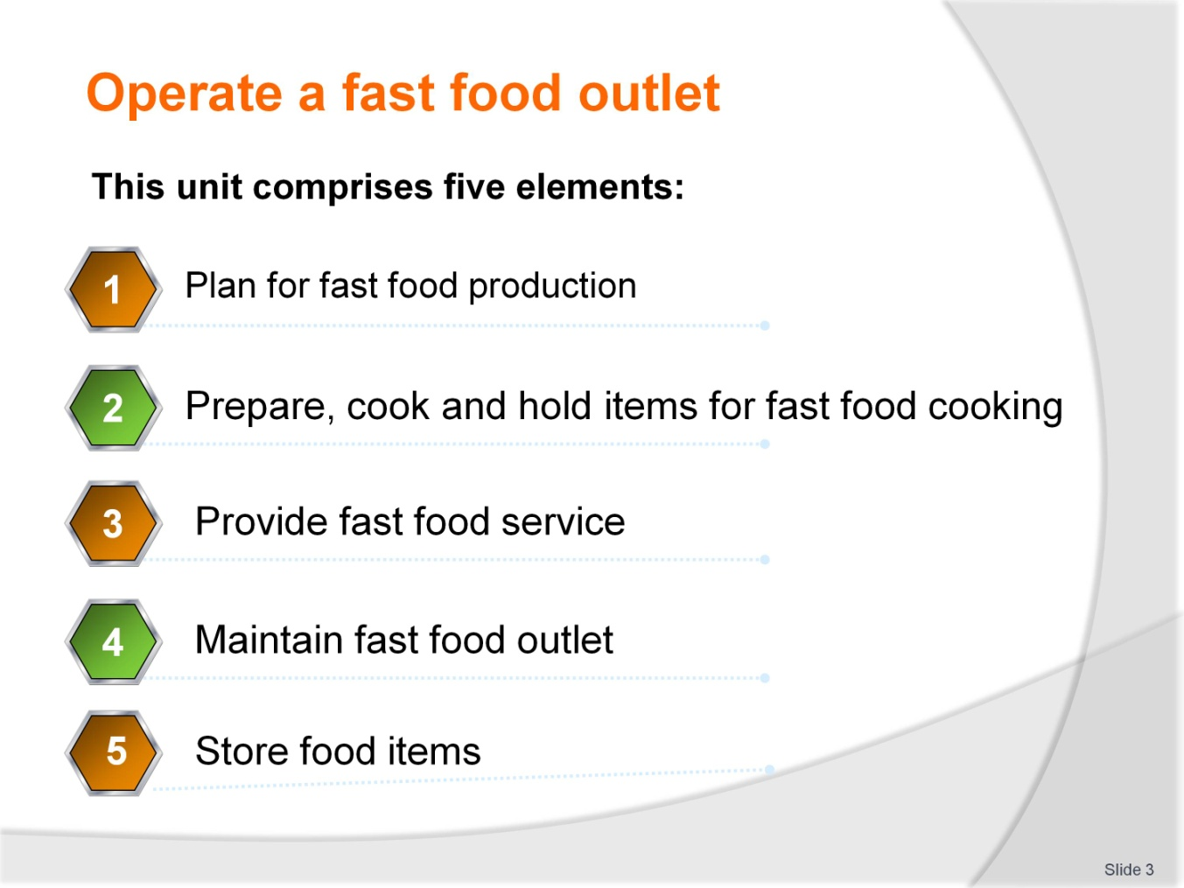
Slide No | Trainer Notes
Trainer to advise
Trainer advises students this Unit comprises five elements, as listed on the slide explaining:
Each Element comprises a number of Performance Criteria which will be identified throughout the class and explained in detail
Students can obtain more detail from their Trainee Manual
The course presents advice and information but where their workplace requirements differ to what is presented, the workplace practices and standards must be observed.

Slide
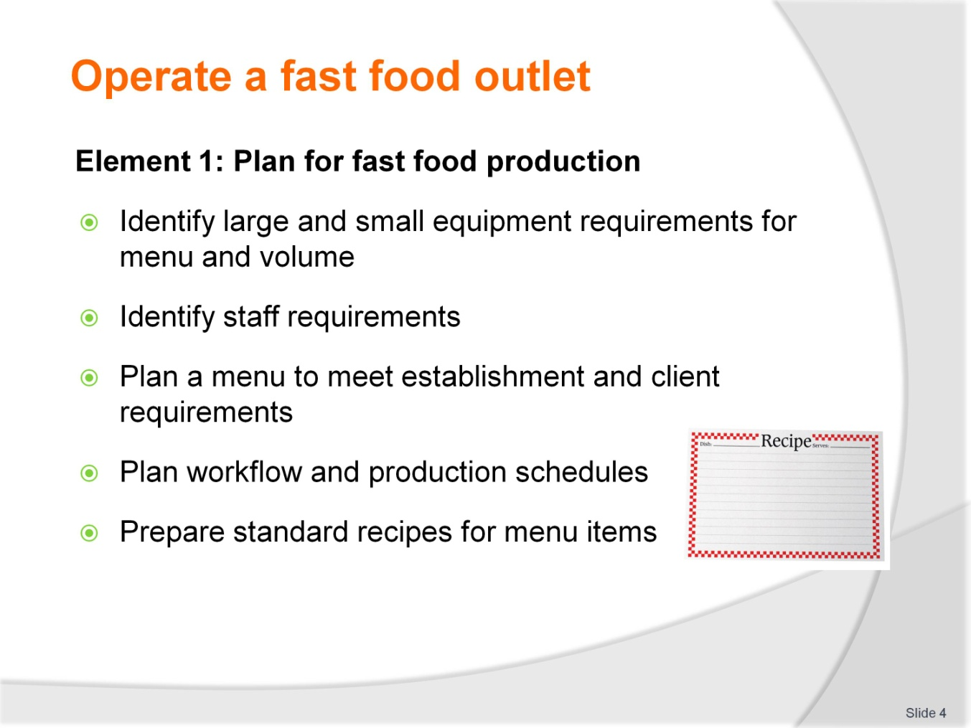
Slide No | Trainer Notes
Trainer to advise
Trainer to relate performance criteria to element 1
Performance criteria is the process by which the students training match the learning element
The element is the skill
To assess competency in the skill; the performance criteria is used to outline activities that can be used to assess competency.
The trainer should relate how the performance criteria is related to the element
To be able to Operate a fast food outlet the students must be able to; Plan for fast food production.
The student should be able to do:
Identify large and small equipment requirements for menu and volume
Identify staff requirements
Plan a menu to meet establishment and client requirements
Plan workflow and production schedules
Prepare standard recipes for menu items.

Slide
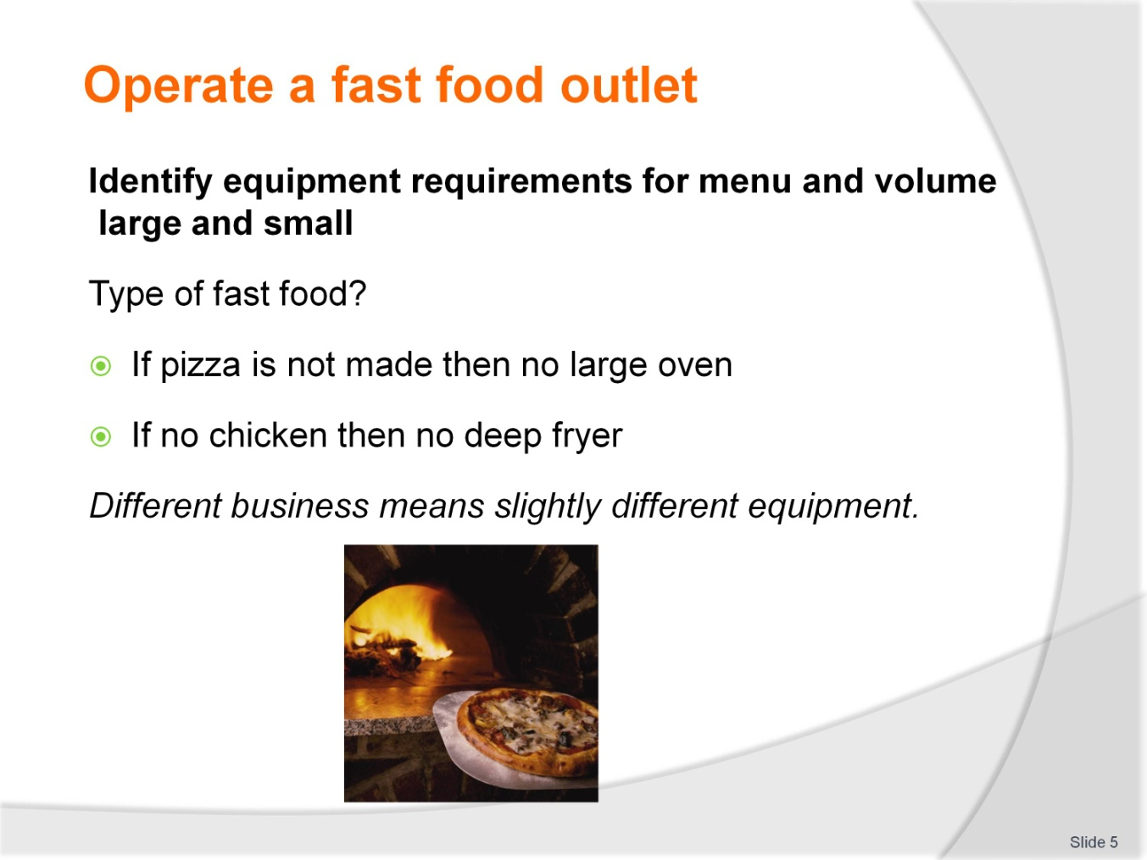
Slide No | Trainer Notes
Trainer to advise
Equipment will vary slightly as type of food produced
When does a fast food outlet become a café which then becomes a restaurant?

Slide
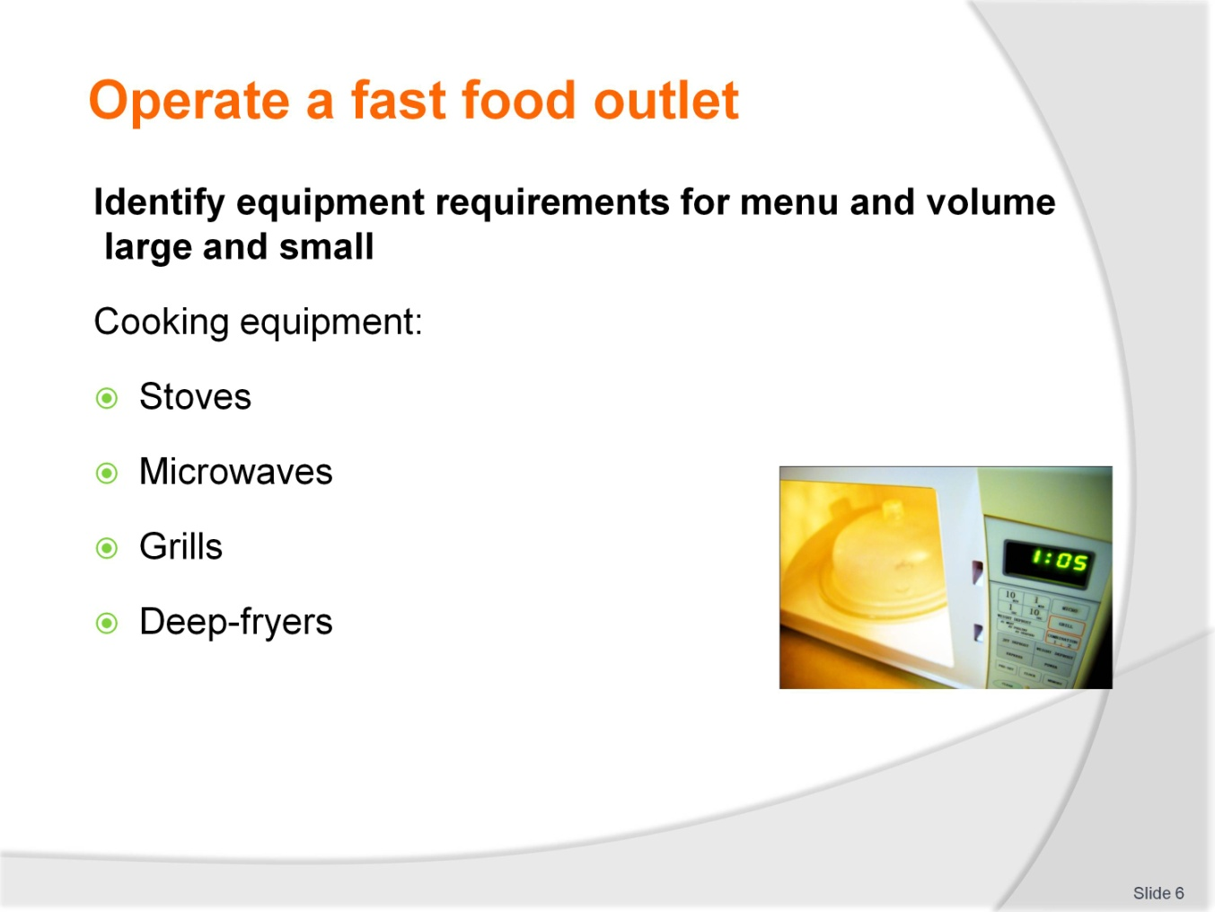
Slide No | Trainer Notes
Trainer to advise
Safe operating of equipment makes working much easier
Staff trained in all aspects.

Slide
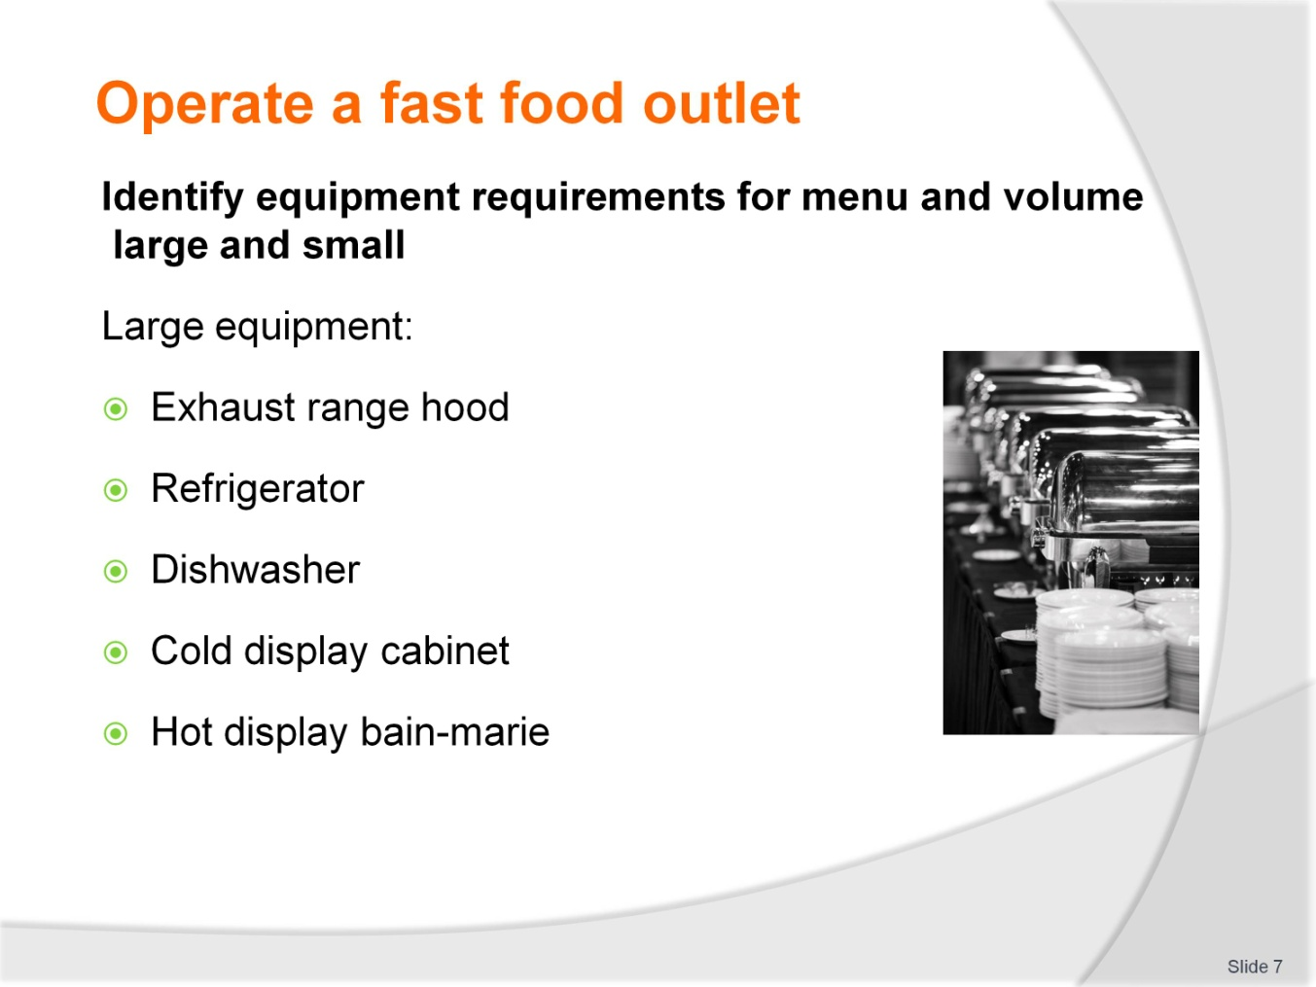
Slide No | Trainer Notes
Trainer to advise
Exhaust range hood to extract hot air from kitchen is an expensive equipment purchase
Expensive to install and expensive to remove if business does not succeed
Exhaust hoods are mandatory where gas is used as a fuel for cooking
If flame is extinguished then there is no build up of poisonous gases
Large equipment used to store foods and clean dishes.

Slide
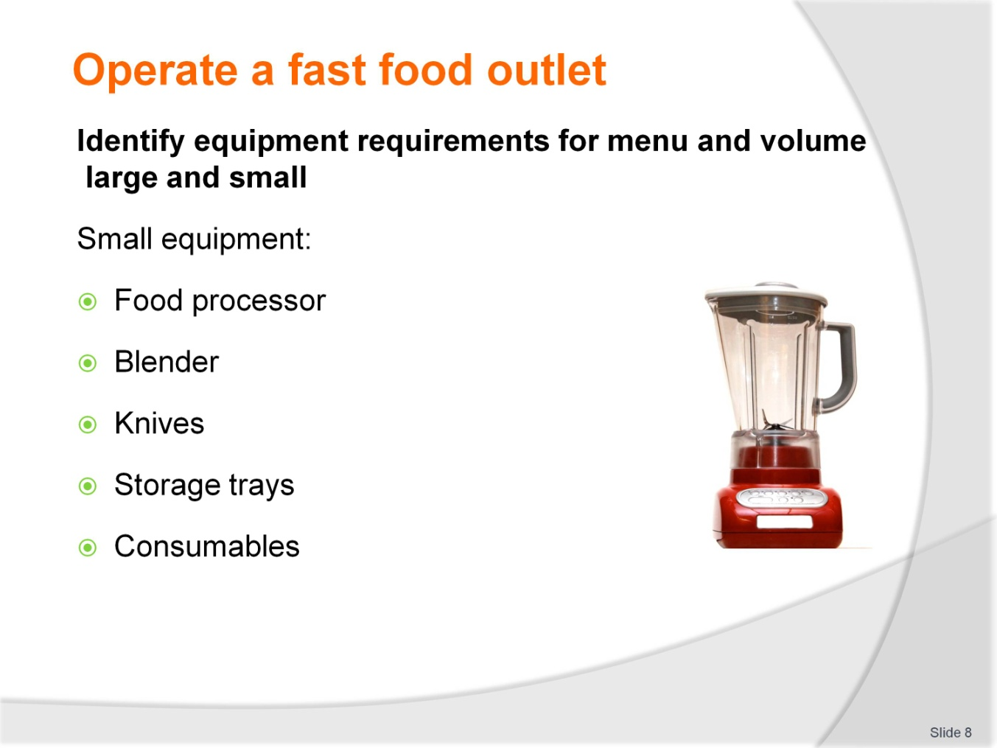
Slide No | Trainer Notes
Trainer to advise
Small equipment used to process foods
Variety will differ slightly depending on style of food outlet
Some outlets will purchase all commodities from larger suppliers and assemble as required
This will reduce the amount of infrastructure and equipment required.
Equipment like
Storage trays and consumables will always be required
Consumables are items such as
paper bags
Take away supplies
Plastic wrap for covering foods
Aluminium foil for covering hot foods.

Slide
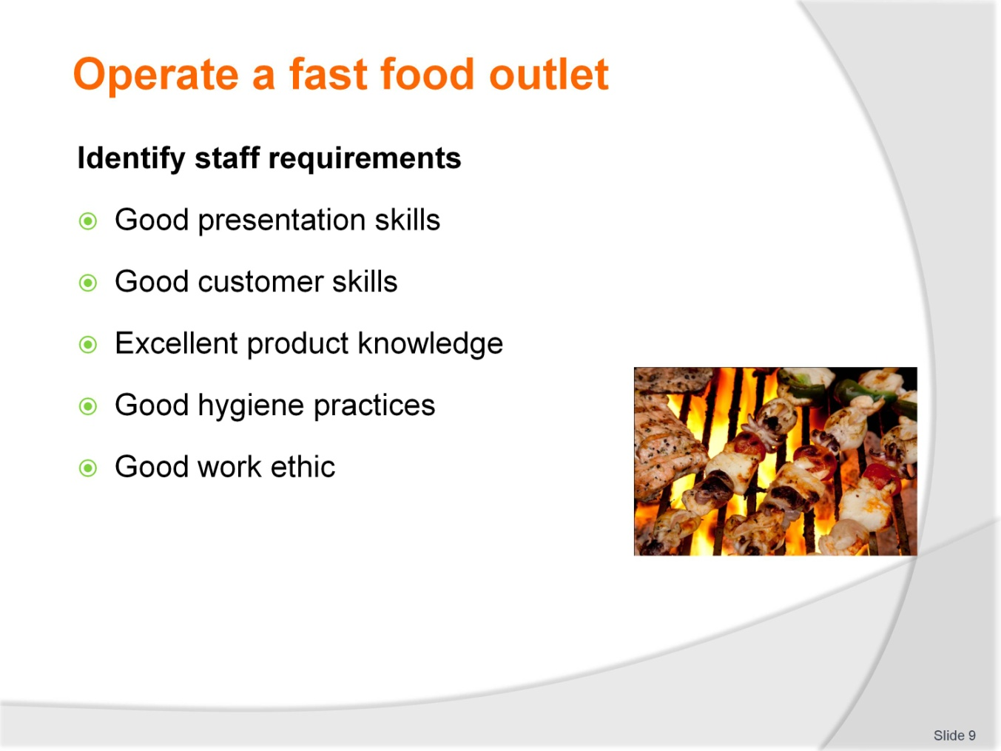
Slide No | Trainer Notes
Trainer to advise
Employing good staff is challenging
Staff should present well to customers
They should be able to engage with customers and give customers a pleasant experience
Staff should have good product knowledge of menu items
Staff should have a good work ethic.

Slide
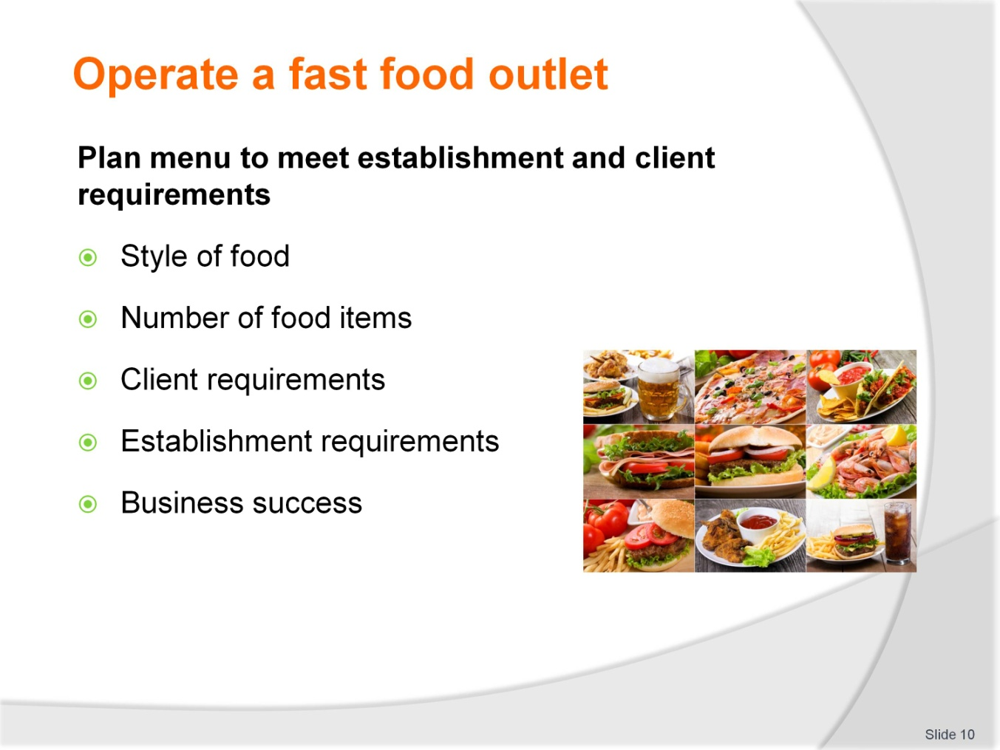
Slide No | Trainer Notes
Trainer to advise
Planning menu to meet establishment and client requirements.
Style of food:
When the style of food has been decided then the menu needs to reflect that style
Menu can have slight variations of style but should be true to form.
Number of food items:
Number of menu items need to be kept to minimum
If pizza is the main style of fast food then do not do burgers
10- to 16 pizza is sufficient; meat based and vegetarian
Drinks also kept to minimum
If coffee is offered and you sell espresso then you may need to employ 1 person just to make coffee.
Client requirements?
What do clients need? If there are 6 businesses selling pizza then the customers do not need another pizza place.
Clients do not need a large choice when ordering fast food.
Student activity 1
Ask students why not? For previous statement.
It takes the client longer to order if the menu is too large
If the menu is large then there is more mise en place required in the kitchen
More staff required
possibility of more waste
Slower service.
Establish requirements?
Quick turnover of clients
Quick sales
Maximum profit from lower costs.
Business success:
All comes from above.

Slide
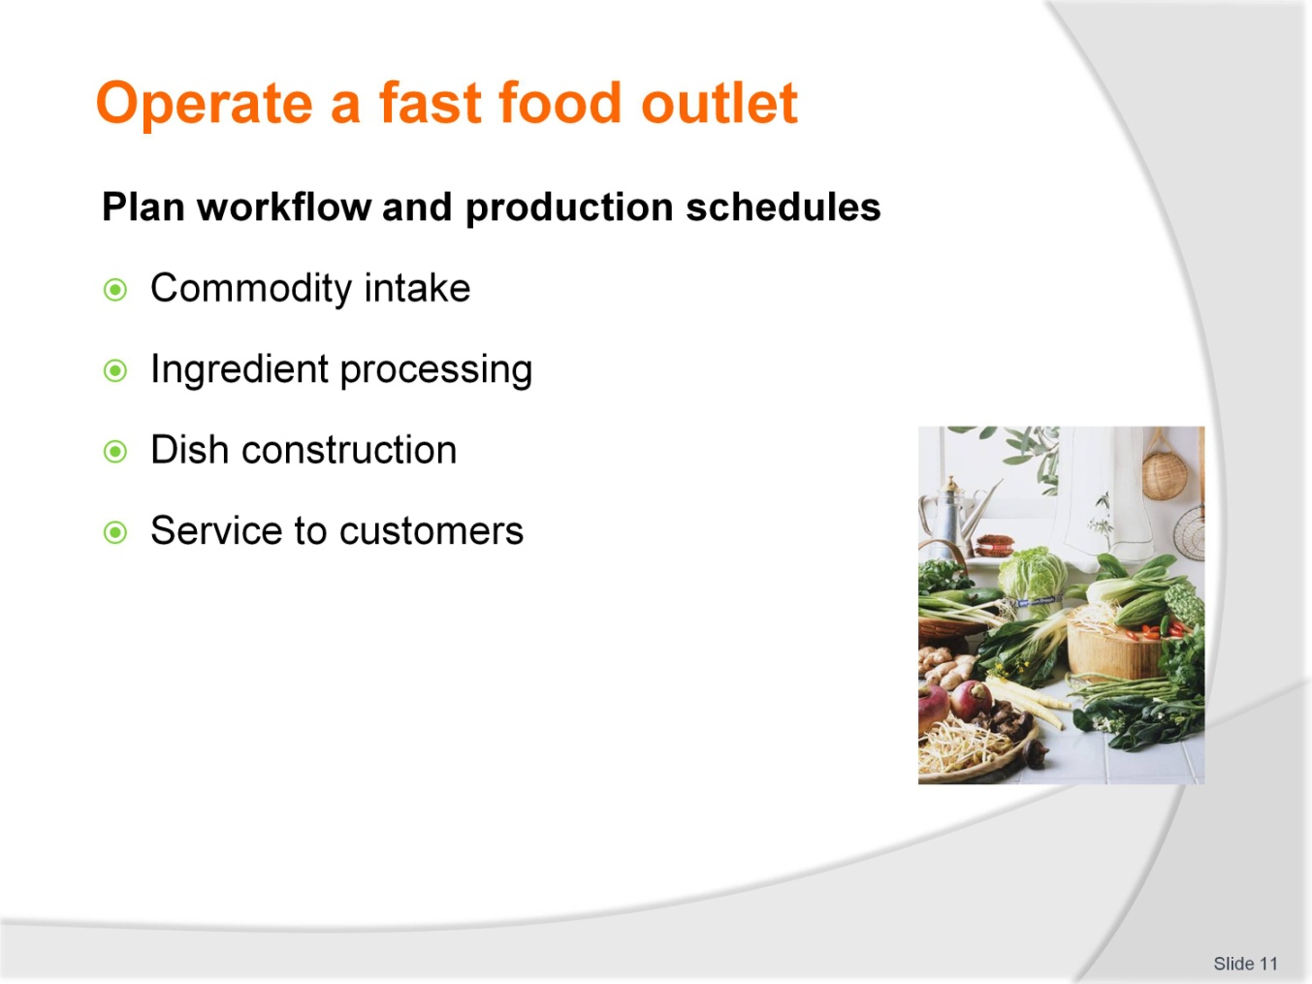
Slide No | Trainer Notes
Trainer to advise
Planning the workflow is about how much has to be done to the commodity after is comes onto the premises
How many elements or parts to each dish
The more processing required the greater the workflow planning required
Dish or menu item construction will always have to be carried out
The number of ingredients that make up the dish will determine the time this steps takes
10 elements take longer than just 4
Service to customers is always the same.
It takes as long to conduct the sale of 20 items to a customer as it does to sell one item
Cleaning after end of business will always have to be done.

Slide
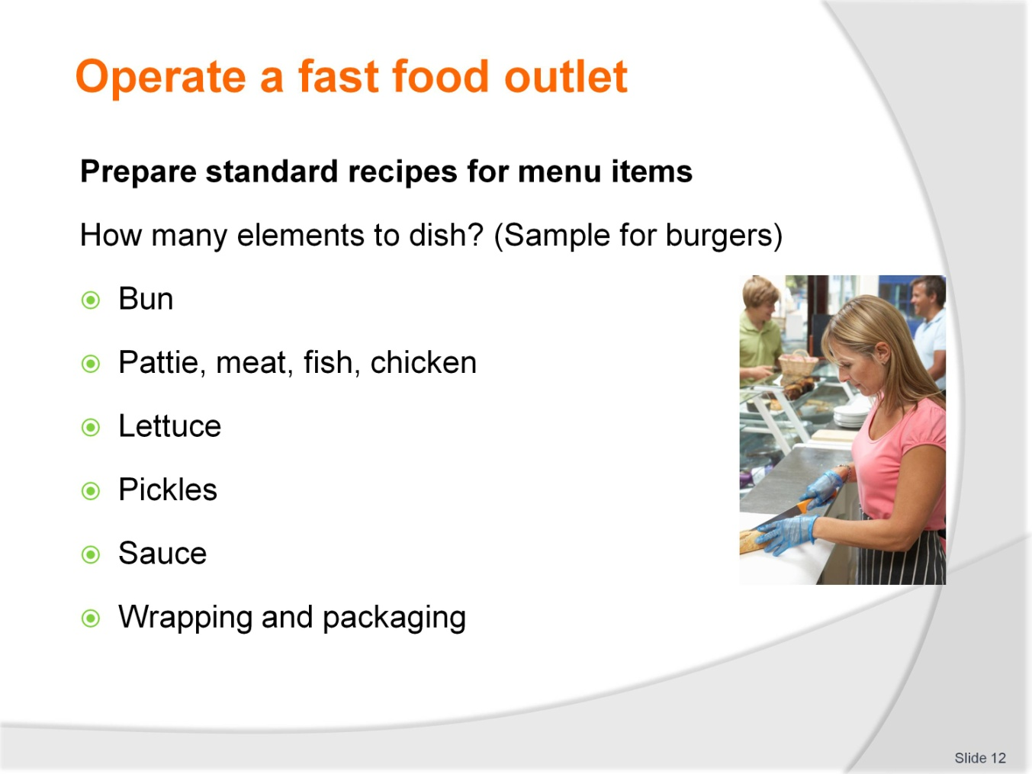
Slide No | Trainer Notes
Trainer to advise
Standard recipes should always produce the same product anywhere in the world that it is used
There is a famous burger chain that has proved this to be correct
The more elements the higher the cost of ingredients and higher cost of labour because it takes longer to construct
This process needs to be implemented for any menu item.
Student Activity 2
The students need to produce a standard recipe for any fast food they can think
List the elements of the purchased product
Pizza?? Dough, sauce, toppings 1 or 5, how much of each, how much cheese
Cooking time
Packaging requirements
Same process for chicken or curry bar selection.

Slide
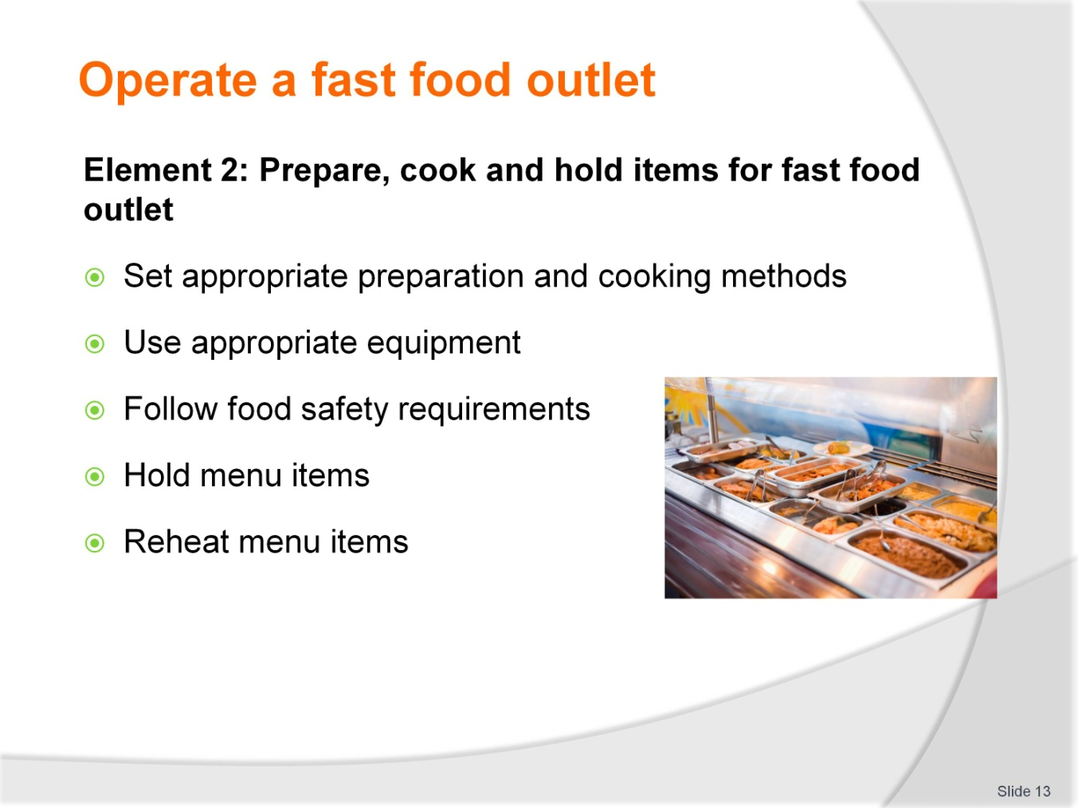
Slide No | Trainer Notes
Trainer to advise
Trainer to relate performance criteria to element 2
Performance criteria is the process by which the students training match the learning element
The element is the skill
To assess competency in the skill; the performance criteria is used to outline activities that can be used to assess competency.
The trainer should relate how the performance criteria is related to the element
To be able to Operate a fast food outlet the students must be able to;
Prepare cook and hold items for fast food outlet.
The student should be able to:
Use appropriate preparation and cooking methods
Use appropriate equipment
Follow food safety requirements
Hold menu items
Reheat menu items.

Slide
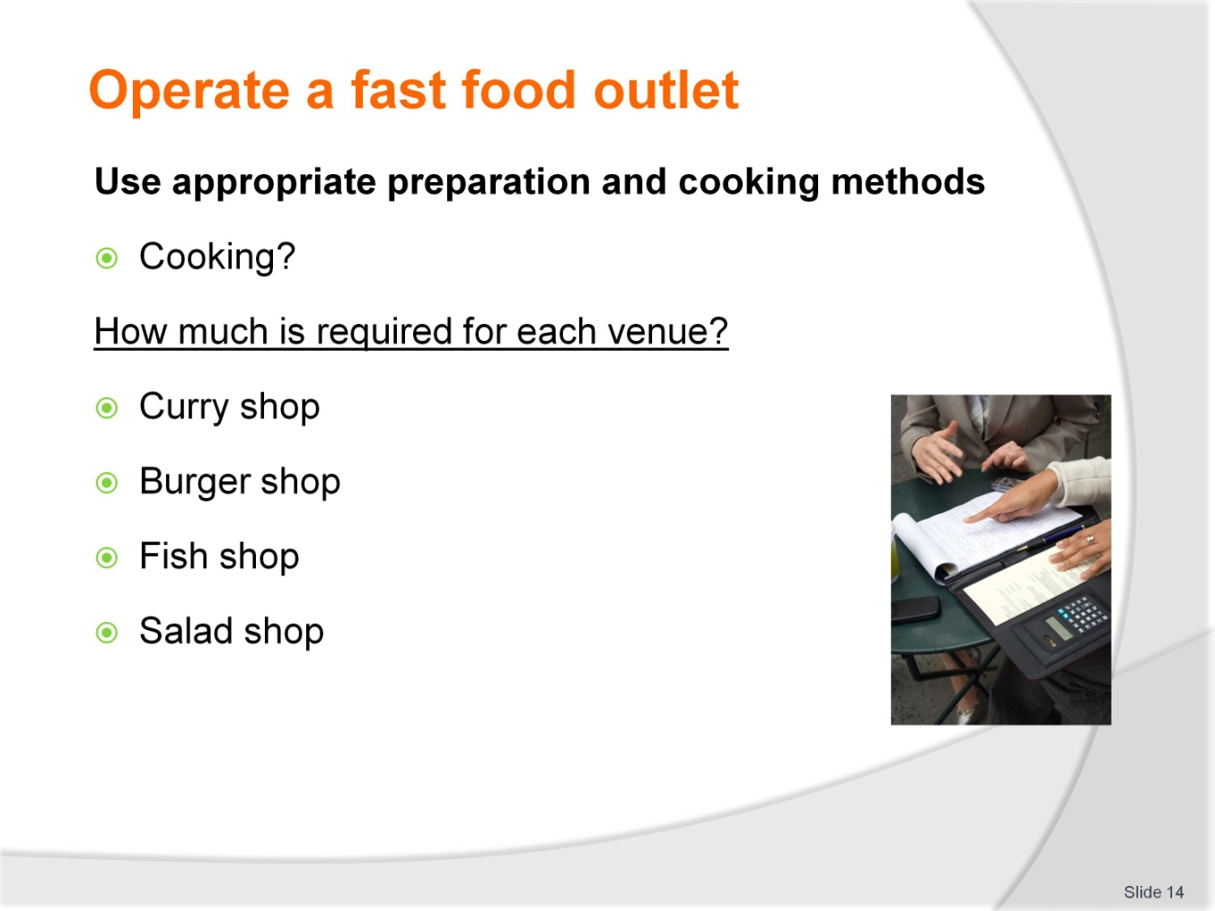
Slide No | Trainer Notes
Student Activity 3
Ask how much cooking is required for each shop
Ask them to list in order of which place might have the most cooking requirements.
Student Activity 4
Ask how much cooking is required for each shop
Sample answer could be this
Burger and fish shop will be equal if just the flesh is to be cooked
If fries are to be offered then that business goes to the higher cooking requirements
Curry bar can purchase all curries in and therefore only has to re-heat, no cooking required
Curries can be reheated in microwave
Salad shop has no cooking requirements; all commodities can be purchased from suppliers.

Slide
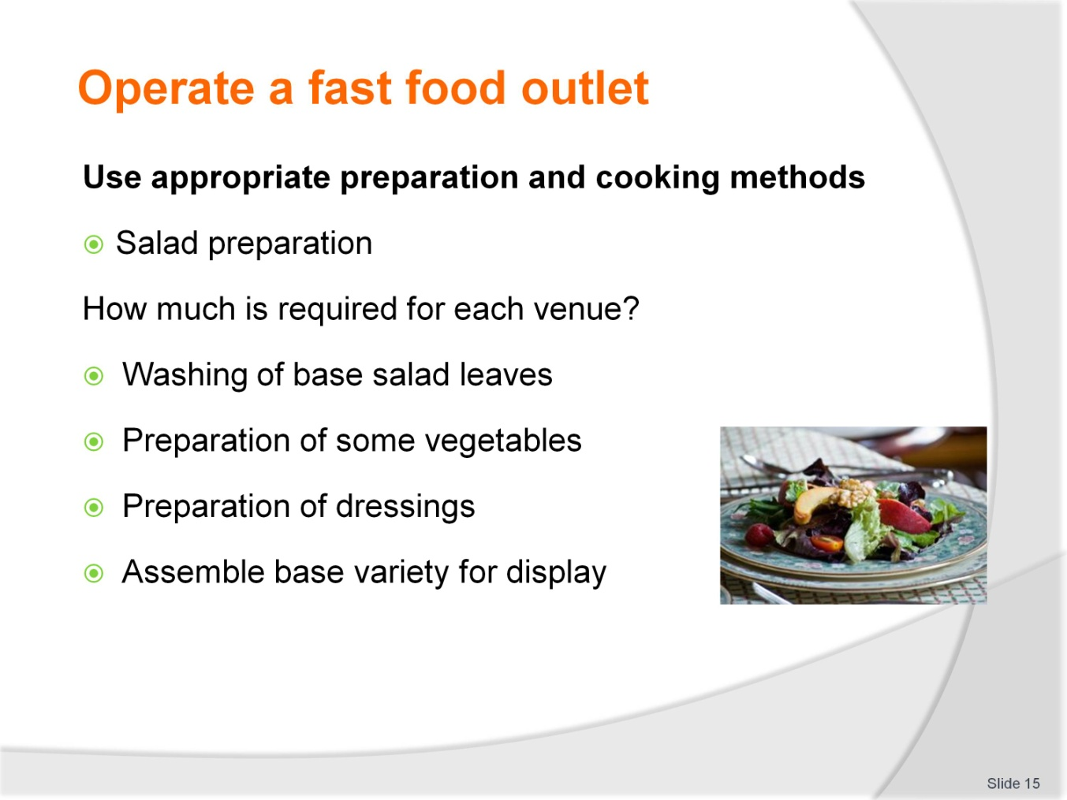
Slide No | Trainer Notes
Student Activity 5
Each menu item will have specific requirements to be carried out before that menu item is ready for sale
A timeline will be need to be developed so decisions can be made as the viability of such menu items
It will vary depending on how enterprise is set up.

Slide
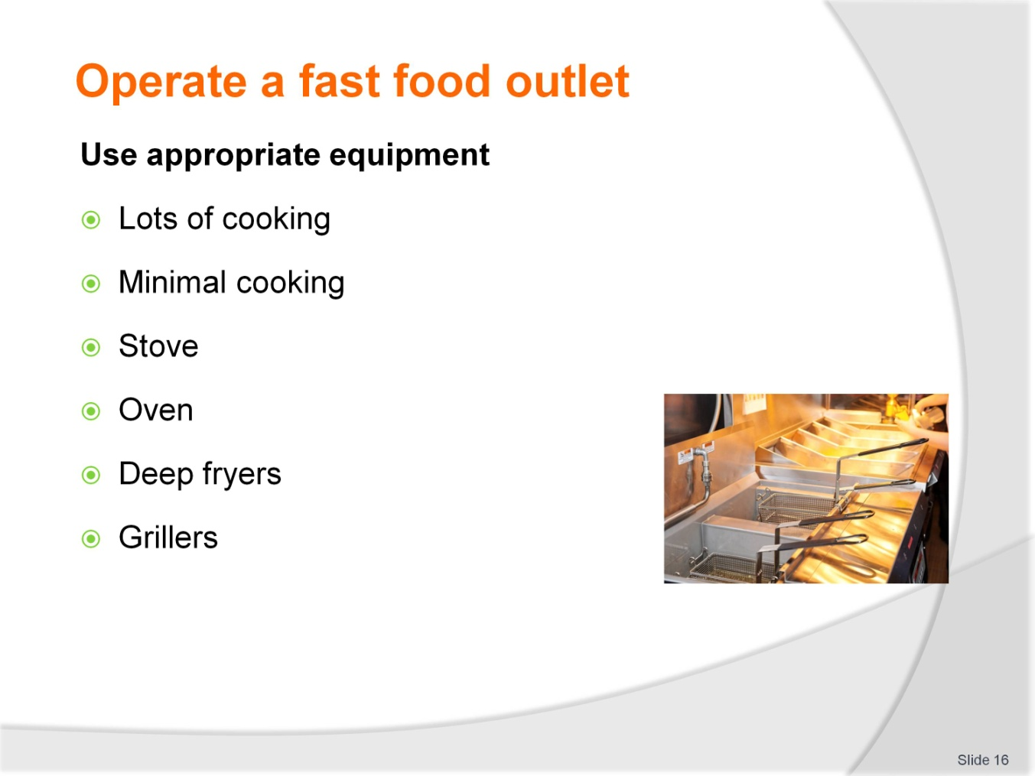
Slide No | Trainer Notes
Trainer to advise:
How the business is set up will determine what equipment is required
Train staff in proper usage of all equipment
Use equipment suitable for the job
If there is going to be lots of deep frying then purchase several large deep fryers
Small ones will not recover heat quick enough to keep up with pace of cooking required
One large one is not sufficient because if it fails to operate then there is no backup and then you have no business
Keep equipment clean and well maintained.

Slide
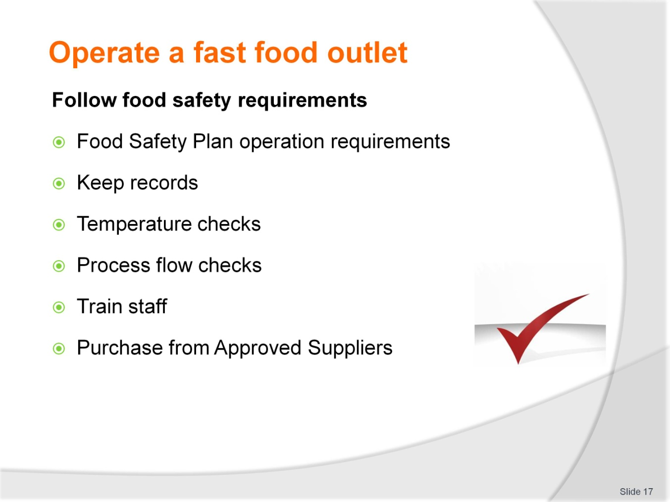
Slide No | Trainer Notes
Trainer to advise
All business must operate with a food safety plan:
Food safety plans outline the steps that are being followed by the business to keep food safe for human consumption
If staff are trained in these requirements and staff follow the required steps then food produced will be safe to eat
A food safety plan is designed to minimise the possibility of causing any adverse reaction in people who consume the food
It is not a guarantee.

Slide
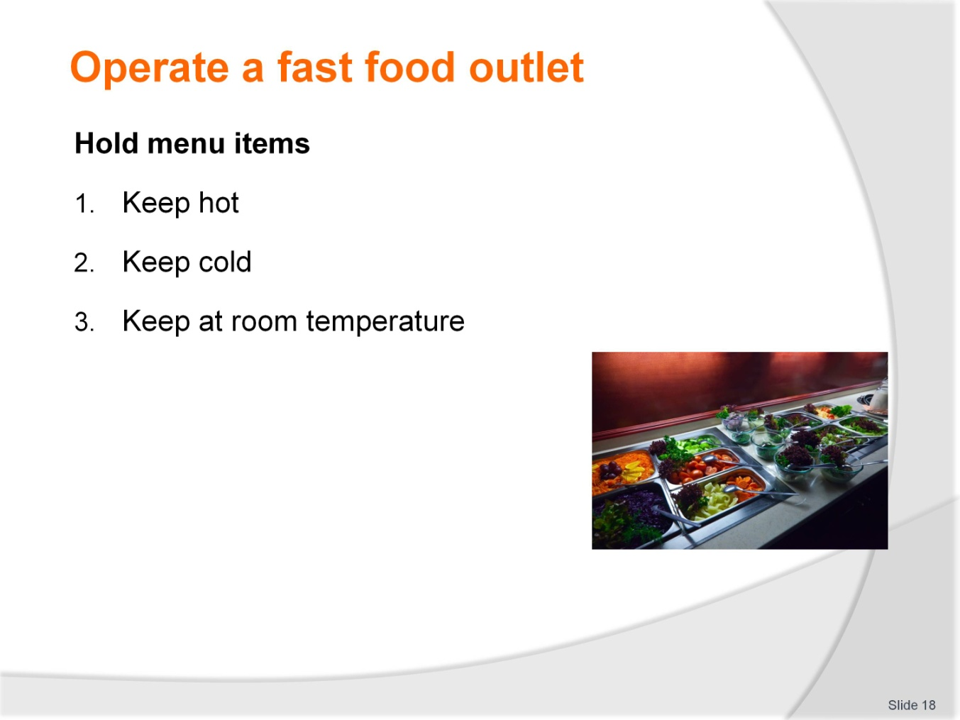
Slide No | Trainer Notes
Trainer to advise
Hold is a term to describe the time between when the food has been cooked until it is delivered to the customer for eating
In a curry shop the curry is cooked and held hot in a Bain Marie to keep it hot until a customers requests a serve
If it was a salad shop then the salad will have to be kept chilled with no dressing until sold so the leaves remain crisp
The salad has been ‘held” in a suitable state.

Slide
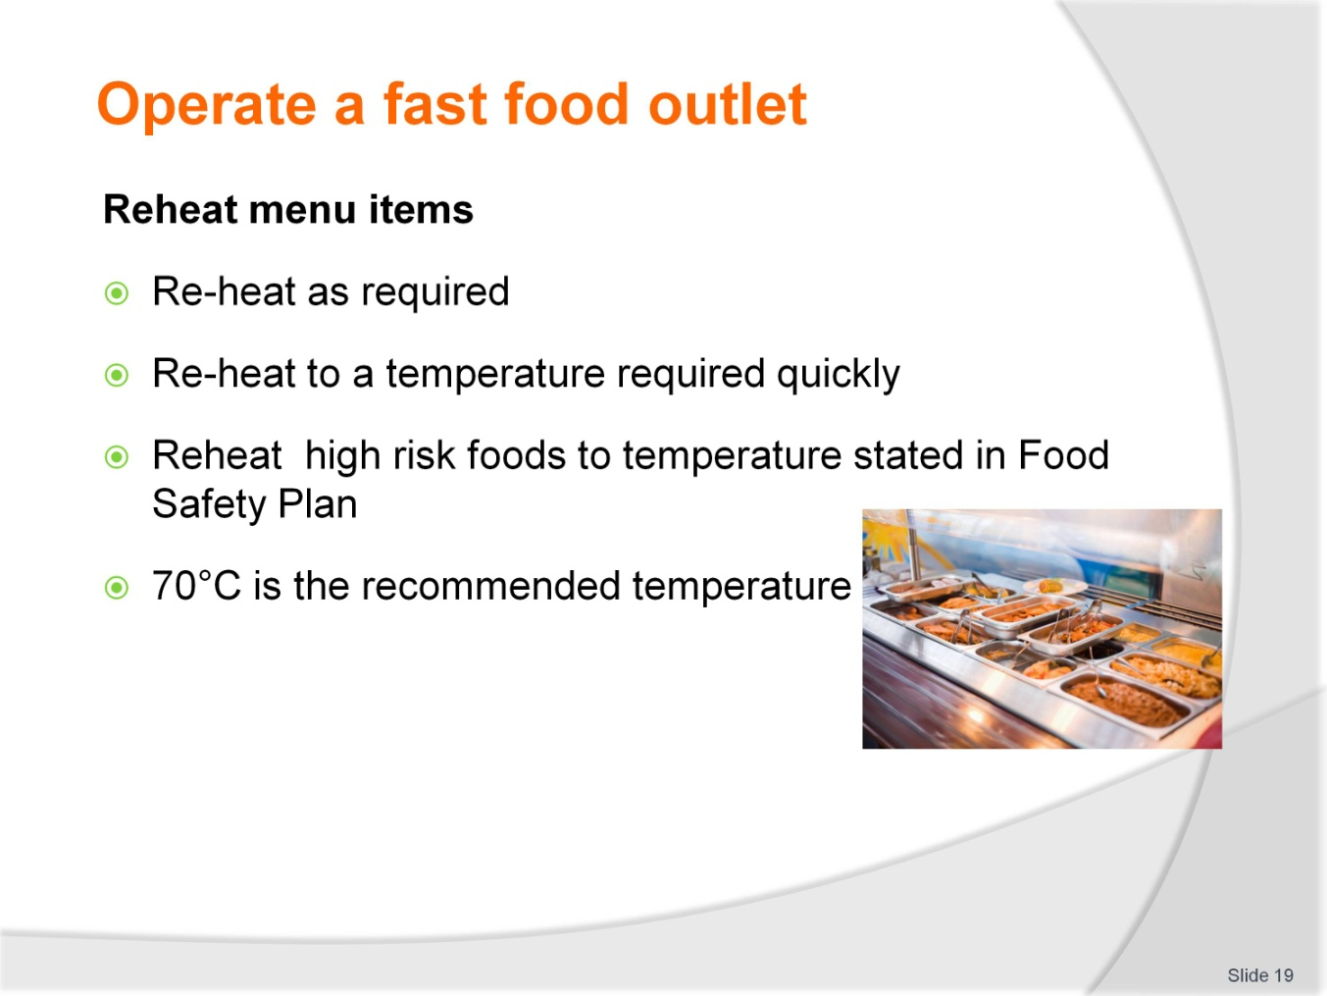
Slide No | Trainer Notes
Trainer to advise
If food has been precooked as part of the production schedule then it only needs to be reheated for service
Reheat only what is required
Reheat high risk foods to at least 70°C.

Slide
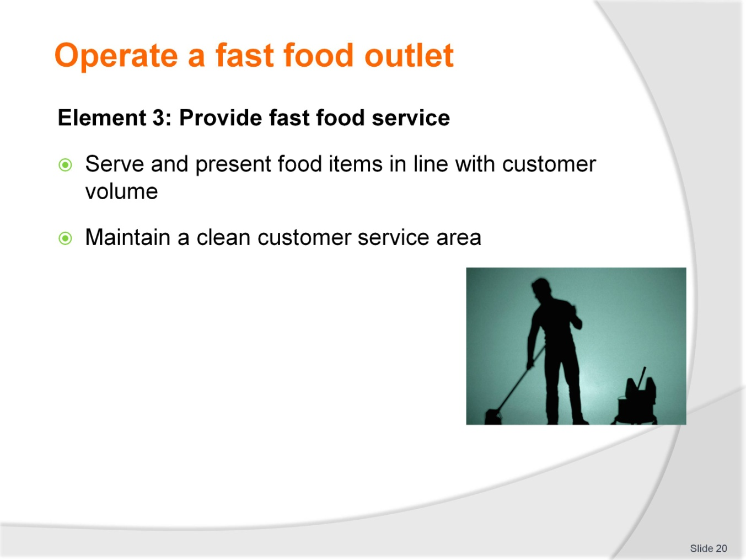
Slide No | Trainer Notes
Trainer to advise
Trainer to relate performance criteria to element 3
Performance criteria is the process by which the students training match the learning element
The element is the skill
To assess competency in the skill; the performance criteria is used to outline activities that can be used to assess competency
The trainer should relate how the performance criteria is related to the element
To be able to Operate a fast food outlet the students must be able to; Provide fast food service.
The student should be able to do:
Serve and present food items in line with customer volume
Maintain a clean customer service area.

Slide
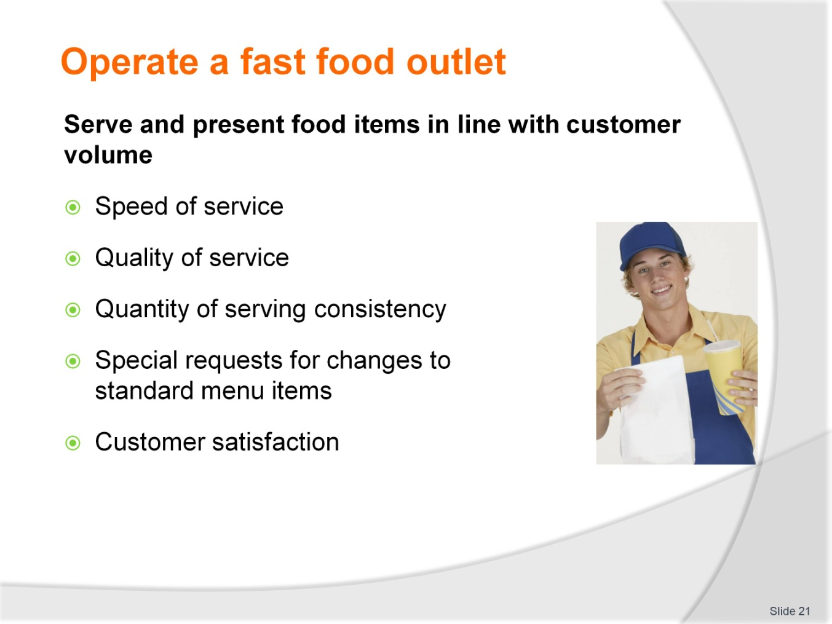
Slide No | Trainer Notes
Trainer to advise
When serving fast food there is going to be peaks and troughs in customers requiring product
Process can be achieved when there is no pressure
But can process quality be maintained when pressure to serve more customers in timely manner still be achieved
People are not machines. They can only do so much in a certain time
With practice and proper equipment efficiencies can be achieved
Sometimes more staff have to be added
Sometime better equipment may be needed
Depending where the weak point in the process is happening
Staff may be very good but if equipment is 2nd rate then service cannot be improved
If equipment is the best and staff are struggling then extra staff can make it work better.

Slide
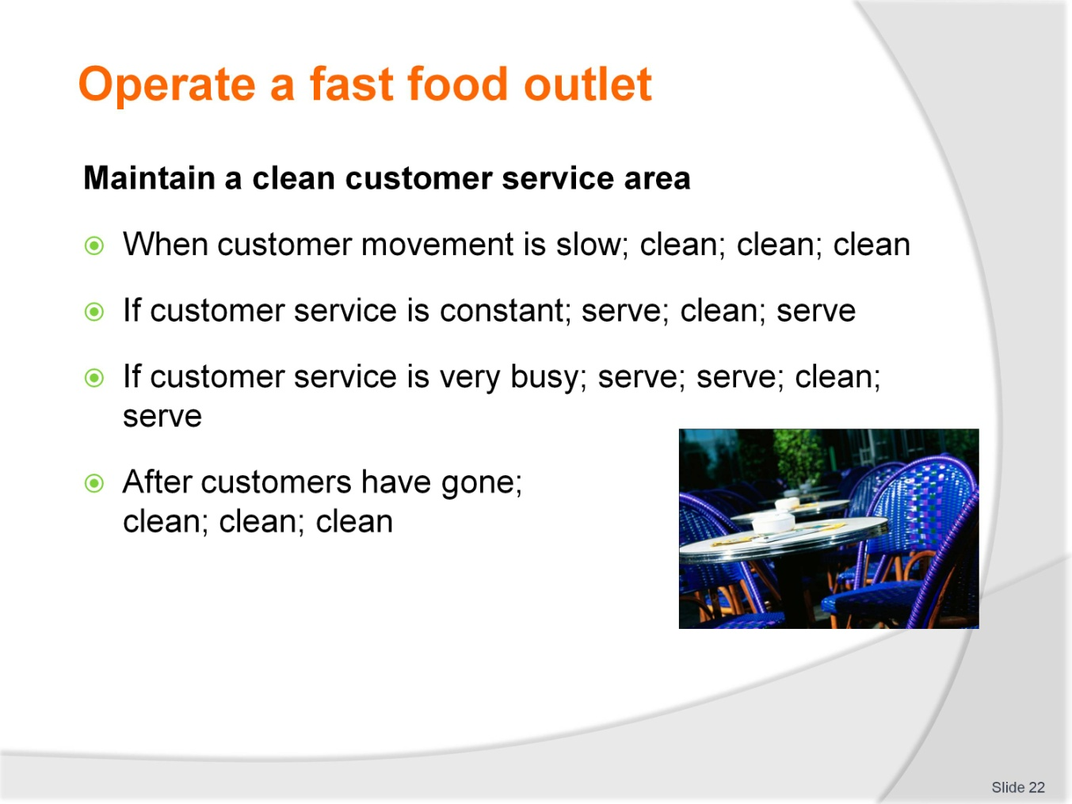
Slide No | Trainer Notes
Trainer to advise
The customer service area is where the customers interact with the business
What the customers see here is their perception of the enterprise
It does not matter how much money is spent on advertising to say that the stores are cleanest in the city
What the customers see is what they will think
Keep the customer service area clean at all times
Both front of counter and behind counter
Keep all areas of food enterprise clean.
Remember
The biggest burger chain in the world rates cleaning of premises at the same level as quality of product that it sells.

Slide
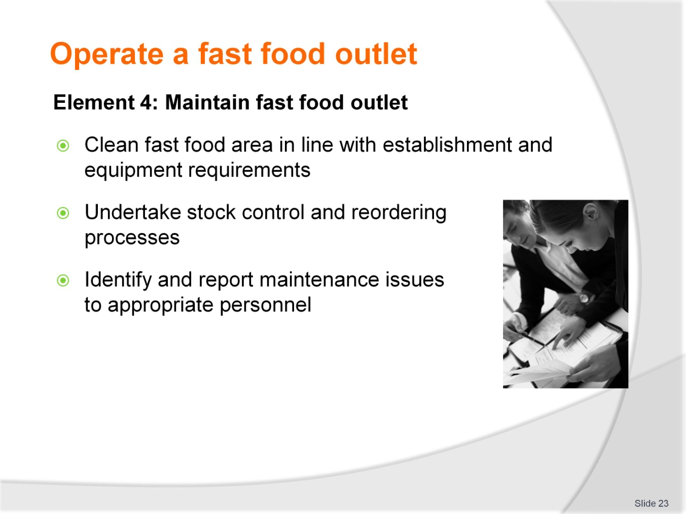
Slide No | Trainer Notes
Trainer to advise
Trainer to relate performance criteria to element 4
Performance criteria is the process by which the students training match the learning element
The element is the skill
To assess competency in the skill; the performance criteria is used to outline activities that can be used to assess competency
The trainer should relate how the performance criteria is related to the element
To be able to Operate a fast food outlet the students must be able to; Maintain fast food outlet.
The student should be able to do:
Clean fast food area in line with establishment and equipment requirements
Undertake stock control and reordering processes
Identify and report maintenance issues to appropriate personnel.

Slide
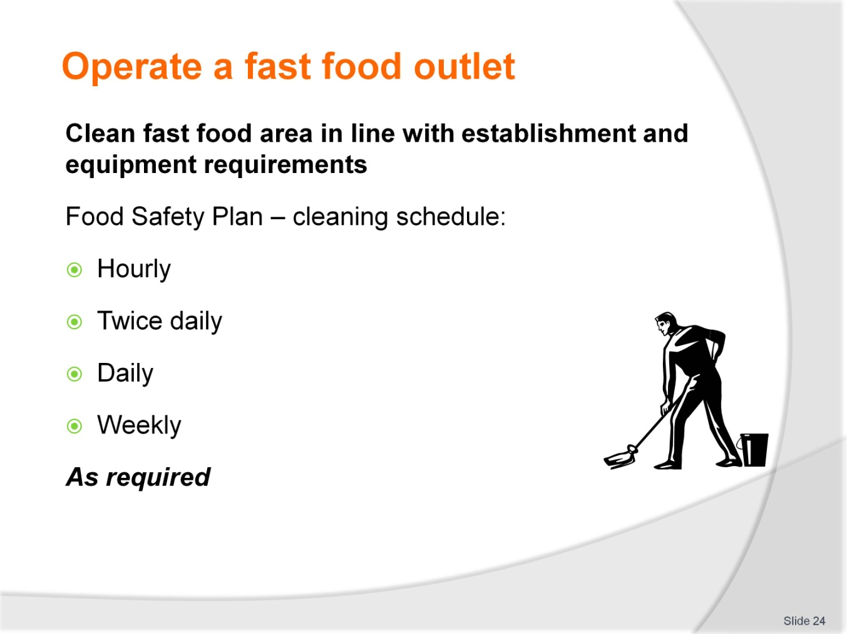
Slide No | Trainer Notes
Trainer to advise
Cleaning is integral part of the smooth operation of a fast food outlet
As stated; cleanliness of premises is how customers will rate quality of product
Nobody buys from dirty food premises
Even their own kitchens may not be as clean, that is why they come to you
Food safety plan must have a cleaning schedule
What is to be cleaned; when it is to be cleaned; who is to clean; with what it is to be cleaned; how often it is to be cleaned
And when it has been cleaned on the hour every hour for the last 6 hours and some body has accident, then it is to be cleaned immediately to the required condition and standard; AS REQUIRED mean just that.

Slide
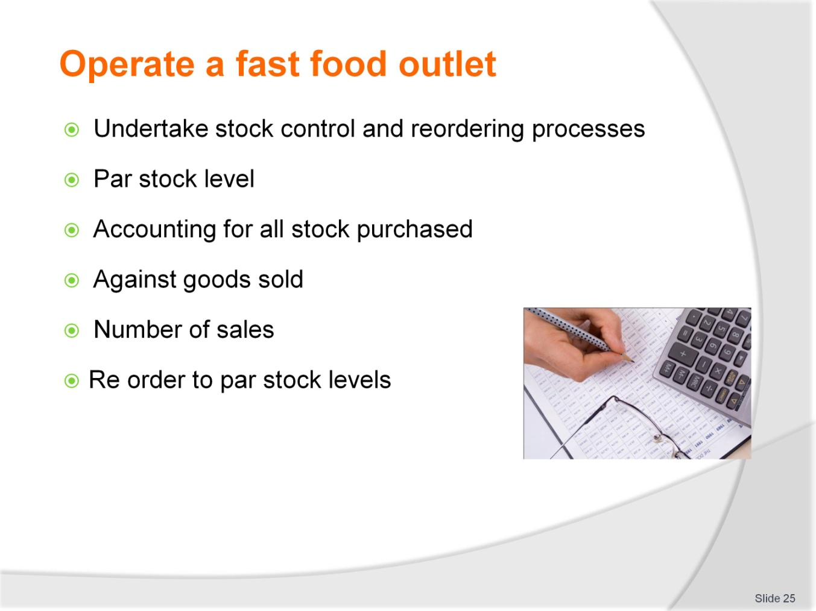
Slide No | Trainer Notes
Trainer to advise
Carrying too much stock is a strain on money invested in business
Determine par stock levels
This is minimum stock required to match expected sale of product
There should always be allowances for extra sales
Lost sales is lost revenue and lost growth of business
If you have par stock of 15
Sale average around 12
Sometimes 9; sometimes 14
So the buffer for extra sales is 25% extra stock
If 11 are sold then 11 are ordered to make back up to 15
When there is a surge in sales and they exceed 15 then next order is for 20
If sales drop then less can be ordered next time but if sales increase and stay increased then you have stock to make sales.

Slide
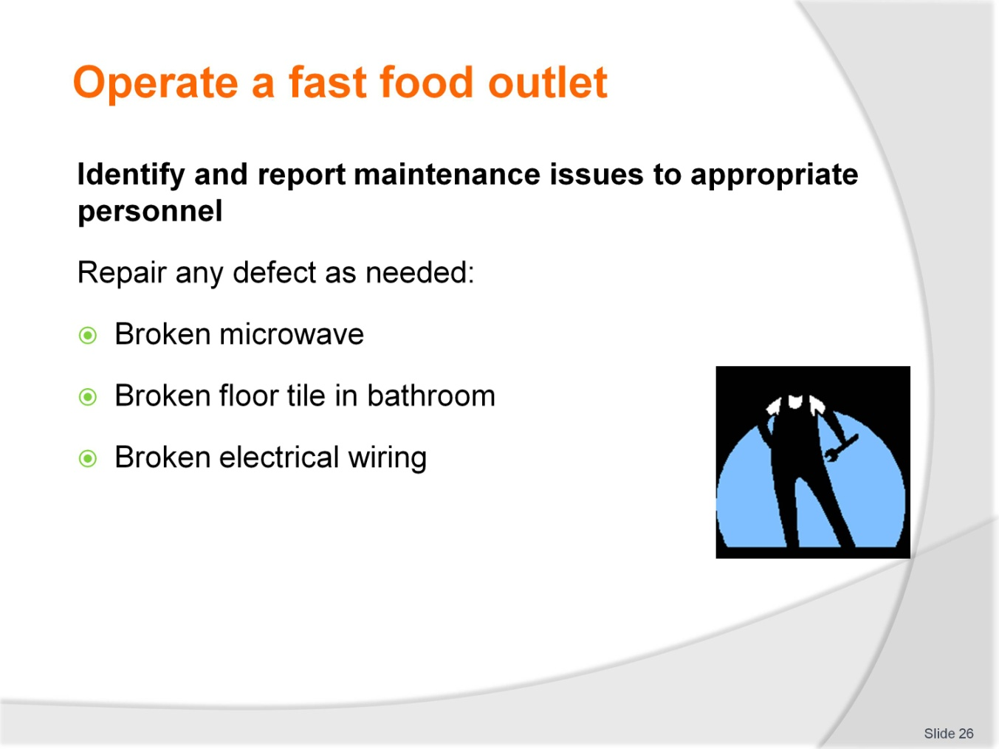
Slide No | Trainer Notes
Trainer to advise
Defective equipment and amenities area are inefficient and dangerous to the health of the business
Equipment that is not working will slow down working potential of staff and speed of service
A broken floor tile is dangerous to customers and staff
No staff; no production
Injured customers; no business.

Slide
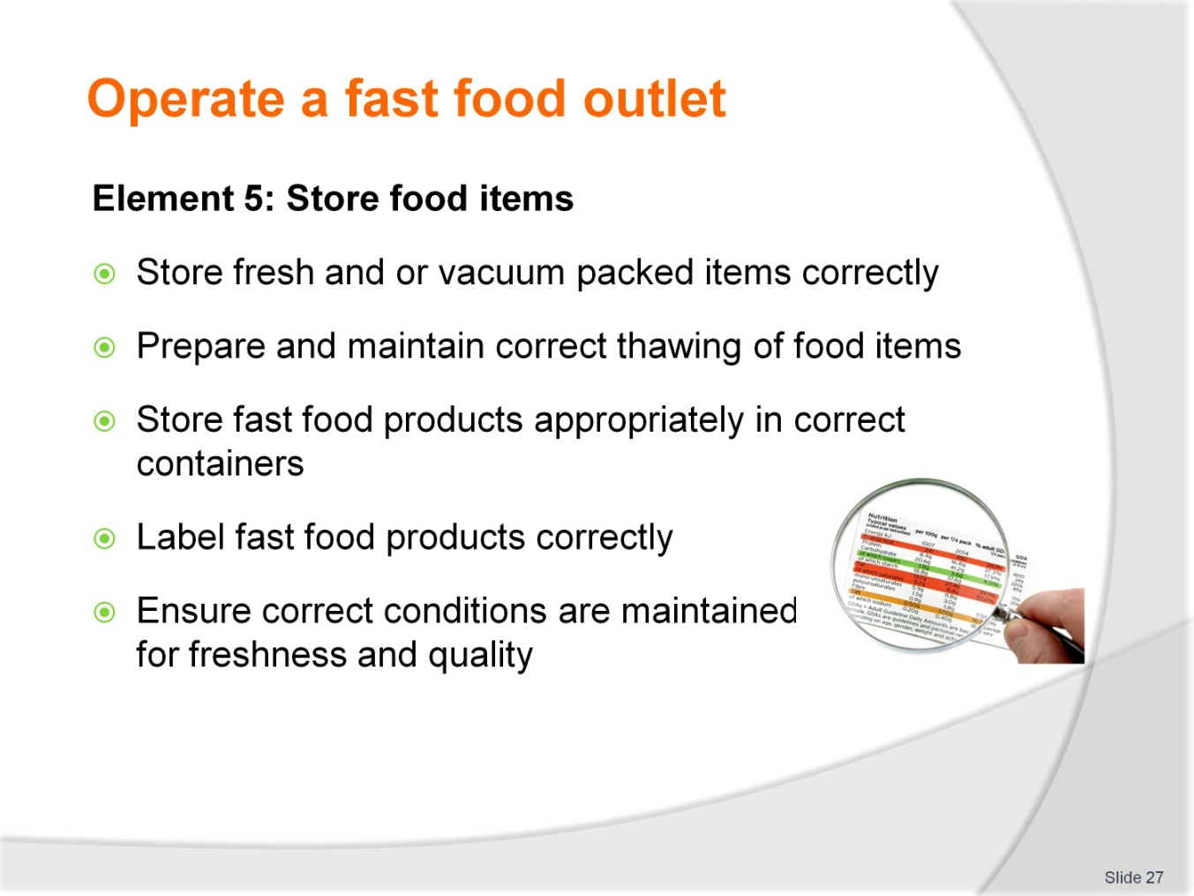
Slide No | Trainer Notes
Trainer to advise
Trainer to relate performance criteria to element 5
Performance criteria is the process by which the students training match the learning element
The element is the skill
To assess competency in the skill; the performance criteria is used to outline activities that can be used to assess competency
The trainer should relate how the performance criteria is related to the element
To be able to Operate a fast food outlet the students must be able to; Store food items.
The student should be able to do:
Store fresh and/or vacuum packed items correctly
Prepare and maintain correct thawing of food items
Store fast food products appropriately in correct containers
Label fast food products correctly
Ensure correct conditions are maintained for freshness and quality.

Slide
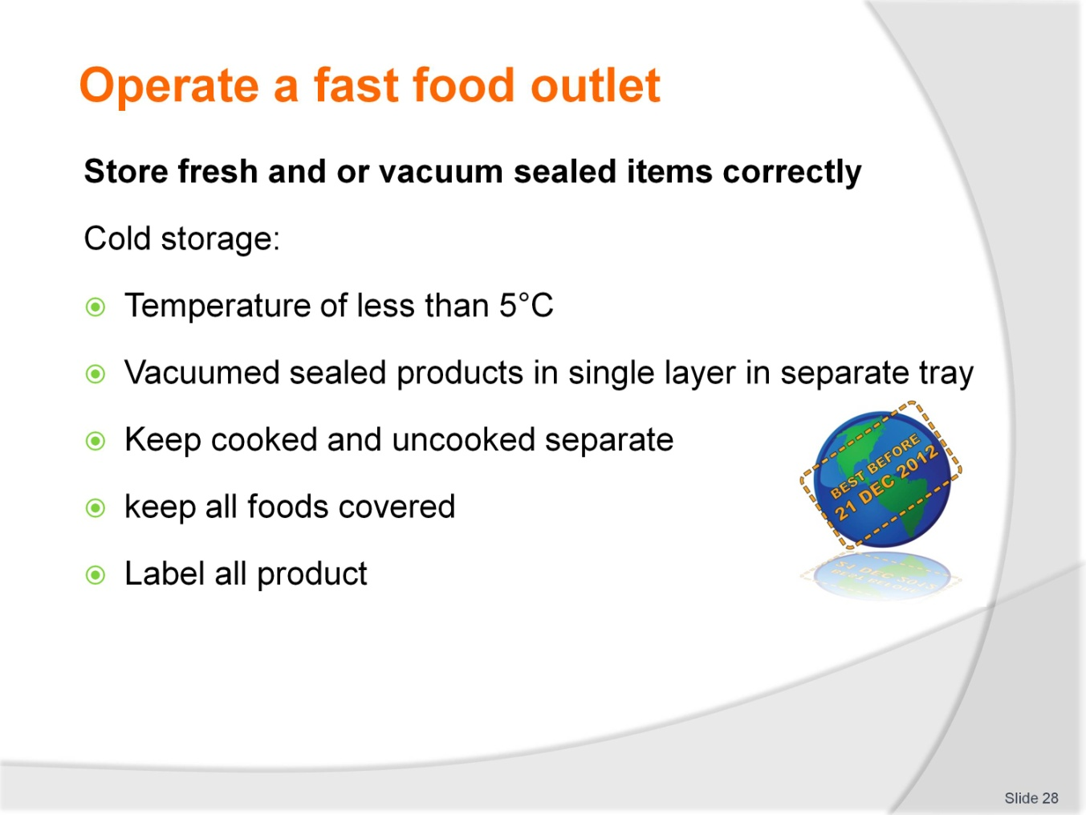
Slide No | Trainer Notes
Trainer to advise
Three food storage areas in a food store selling food to customers
The other storage area is for chemical; no food or product used with the food is to be stored in chemical store
Dry store is for food that can stand at room temperature
Fresh product needs to be chilled to lessen potential growth of bacteria and to extend the ‘life’ of the product
Rate of decomposition is less when temperature is reduced
Keep everything covered
Label all products for easy identification.

Slide
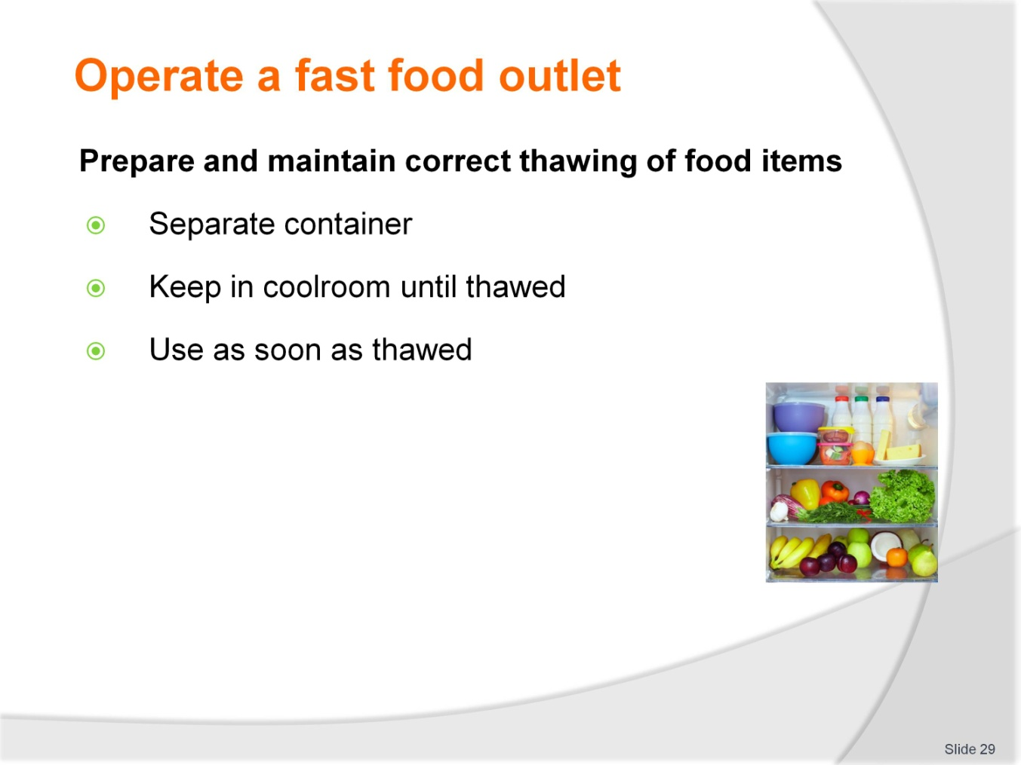
Slide No | Trainer Notes
Trainer to advise
Best place to thaw frozen product is in clean container large enough to hold any liquid that comes out of product when frozen state has ceased
Coolroom that has temperature of less than 5°C
Use product as quickly as possible
Thawed food does not have the same life span as when it was fresh.

Slide
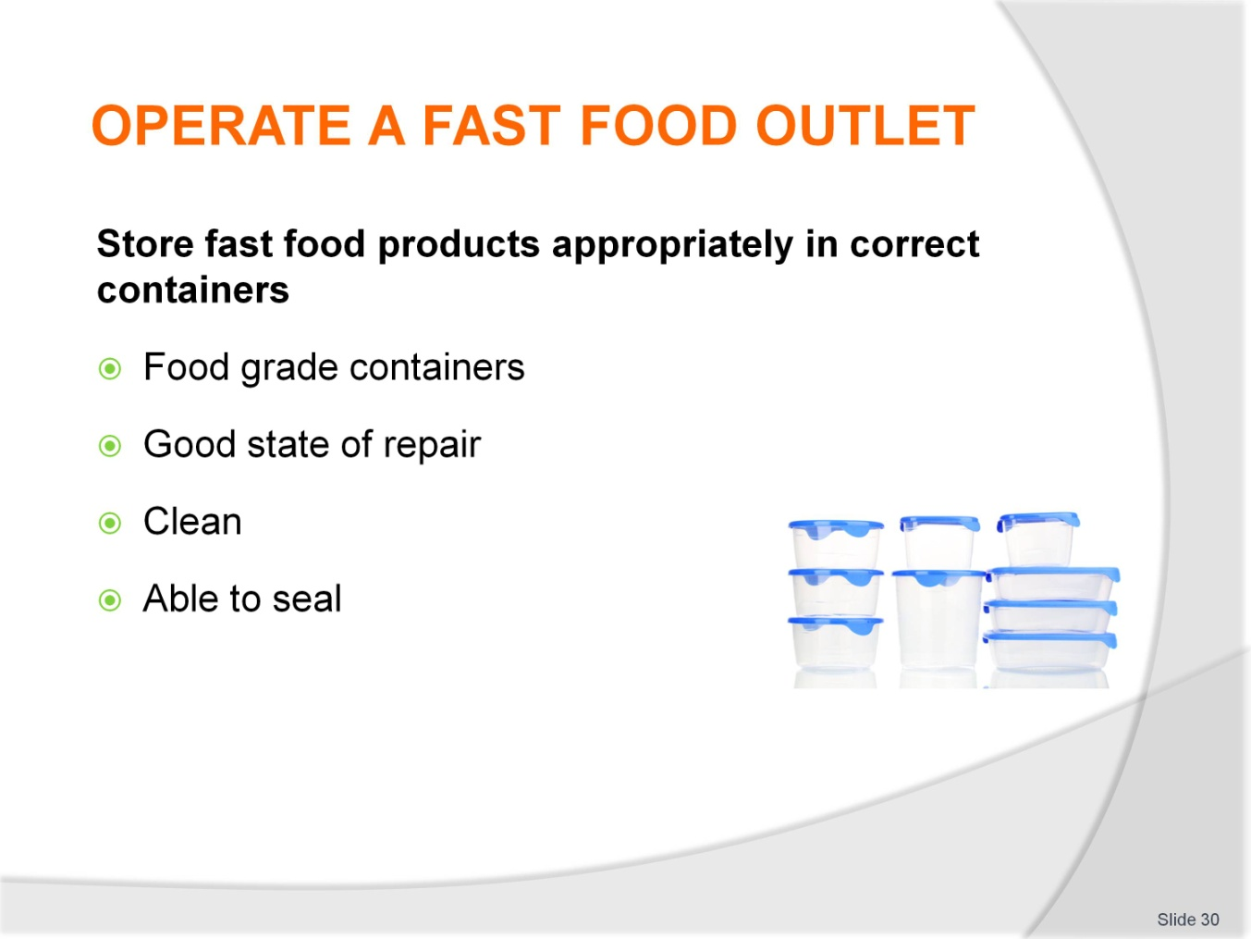
Slide No | Trainer Notes
Trainer to advise
All food needs to be stored in containers suitable for the task
Stainless steel is best but good quality plastic. That is durable able to protect the food and will not contaminate food with compounds from plastic. is acceptable
Always, containers must be clean before using to put other food in
Containers must be able to be sealed; edges will not cut plastic wrap when it is used to seal container.

Slide
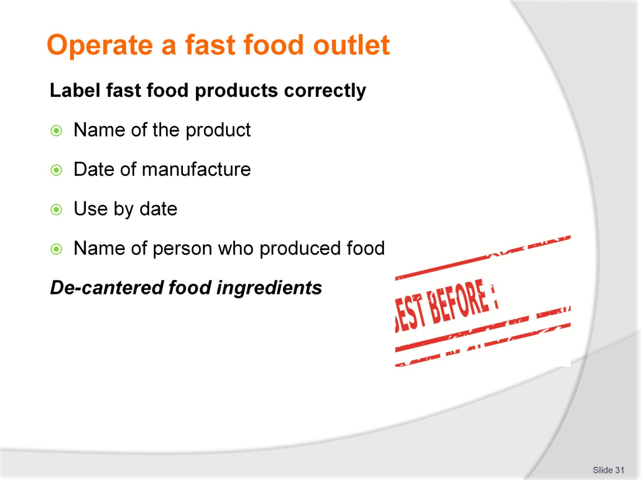
Slide No | Trainer Notes
Trainer to advise
Food stored in coolroom
All foods stored in coolroom need to be labelled correctly
Food de-cantered from tins and boxes and placed into new clean containers needs to be labelled correctly.

Slide
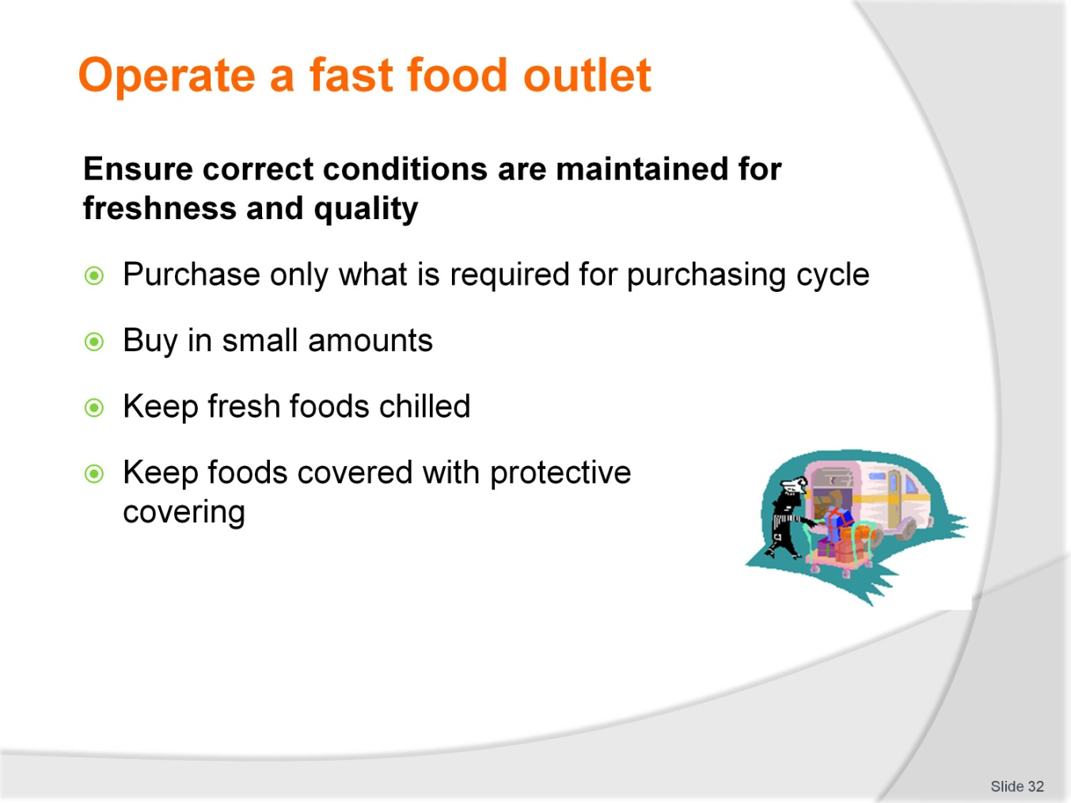
Slide No | Trainer Notes
Trainer to advise
To ensure freshness in foods it is good practice to purchase in small amount depending on rate of usage
Keep fresh foods chilled to keep bacterial growth to minimum and rate of decomposition to minimum
Keep covered to keep foods moist.

Cookery practical classes: Recommended training equipment
The equipment and kitchen consumables required for the delivery of practical cookery training classes are listed below, in the following categories:
A Items of equipment which should be available for trainer and student use in the training kitchen.
B The cleaning equipment and cleaning products which should be available in a cleaning room located adjacent to the kitchen, so that students can clean down to leave the kitchen in “as found” condition at the end of each class or session.
C Consumables other than foodstuffs which need to kept in the kitchen and available for everyday use in each class or session.
D The items required by each student which would make up their own individual use kit of tools and small equipment.
A: Equipment in the training kitchen:
Commercial cooking stove 4 burner minimum  Stainless steel workbench  Stainless steel sinks  Dishwasher  Refrigeration  Freezers  Cooking pots, multiple sizes  Lids for pots  Frypan  Woks  Chinois of various sizes  Measuring jugs  Mouilis | Food processors  Ramekins  Sieves for dry ingredients  Deep fryers  Steamers  Weighing scales  Baking trays  Roasting dishes  Chopping boards for preparation  Gas fire lighters, cigarette lighters not recommended  Tongs for handling foods  Spiders for handling deep fried foods
B: Cleaning equipment and consumables:
Detergent  Scrubbing brushes  Scourers  Sink plugs  Brooms  Shovel and small brooms | Floor mops  Mop buckets  Wet and dry vacuums  Detergent  Hand dishwashing detergent  Paper hand towel
C: Consumables (non-food) to be available in the kitchen:
Silicon baking paper  Plain white butchers paper  Greaseproof paper  Aluminium foil | Plastic wrap, clear  Plastic sheeting clear  Product boxes of various required sizes  Doyleys as required
D: Student equipment kit should include:
Chefs knife 21 cm  Boning knife 15cm  Paring knives 9cm  Sharpening stone  Honing steel 30cm  Pallet knives  Wooden spoons 3  Whisk 30cm 1  Vegetable peeler  Pastry brush | Piping bags  Piping tubes, various sizes  Spatula, flexible  Tongs  Digital thermometer  Tea towels 6  Cutlery set  Scissors  Fine strainer  Carry case for equipment

Instructions for Trainers for using
PowerPoint – Presenter View
Connect your laptop or computer to your projector equipment as per manufacturers’ instructions.
In PowerPoint, on the Slide Show menu, click Set Up Show.
Under Multiple monitors, select the Show Presenter View check box.
In the Display slide show on list, click the monitor you want the slide show presentation to appear on.
Source: http://office.microsoft.com
Note:
In Presenter View:
You see your notes and have full control of the presentation
Your trainees only see the slide projected on to the screen
More Information
You can obtain more information on how to use PowerPoint from the Microsoft Online Help Centre, available at: http://office.microsoft.com/training/training.aspx?AssetID=RC011298761033
Note Regarding Currency of URLs
Please note that where references have been made to URLs in these training resources trainers will need to verify that the resource or document referred to is still current on the internet. Trainers should endeavour, where possible, to source similar alternative examples of material where it is found that either the website or the document in question is no longer available online.

Appendix – ASEAN acronyms
AADCP | ASEAN – Australia Development Cooperation Program.
ACCSTP | ASEAN Common Competency Standards for Tourism Professionals.
AEC | ASEAN Economic Community.
AMS | ASEAN Member States.
ASEAN | Association of Southeast Asian Nations.
ASEC | ASEAN Secretariat.
ATM | ASEAN Tourism Ministers.
ATPMC | ASEAN Tourism Professionals Monitoring Committee.
ATPRS | ASEAN Tourism Professional Registration System.
ATFTMD | ASEAN Task Force on Tourism Manpower Development.
CATC | Common ASEAN Tourism Curriculum.
MRA | Mutual Recognition Arrangement.
MTCO | Mekong Tourism Coordinating office.
NTO | National Tourism Organisation.
NTPB | National Tourism Professional Board.
RQFSRS | Regional Qualifications Framework and Skills Recognition System.
TPCB | Tourism Professional Certification Board.







